Instructor’s Resource

Lesson to Introduce Energy Drinks
This lesson contains new content to supplement the text’s discussion of energy drinks. This lesson will describe what energy drinks are, the health risks of energy drinks, and safer alternatives to energy drinks.

Lesson Background
Some teens use energy drinks to boost their energy. Energy drinks contain large amounts of caffeine, a substance that increases energy and alertness. Energy drinks also include sugars, vitamins, and other stimulants (substances that increase activity in the nervous system).
Caffeine triggers the release of various hormones, including adrenaline and dopamine. These hormones increase heart rate, blood pressure, oxygen flow, and feelings of pleasure and satisfaction. Caffeine also blocks the effects of adenosine. Adenosine slows down the nervous system and makes you feel tired.
Energy drinks are not the same as sports (electrolyte) drinks. Sports drinks do not contain caffeine. They do contain electrolytes, such as potassium, magnesium, and B vitamins. These substances help replace the fluids and nutrients you lose during exercise.
Energy drinks can increase alertness and attention. This is why some teens use them to stay awake when they feel tired. They can, however, lead to serious health conditions. Energy drinks contain high levels of sugar, caffeine, and other stimulants, which can harm the nervous system. They increase blood pressure, heart rate, and breathing. Side effects of energy drinks can include dehydration (not having enough water in your body), heart conditions (including a fast or abnormal heartbeat), anxiety and nervousness, difficulty sleeping, dental issues (cavities and tooth decay), diarrhea, and weight gain. More than 1,000 teens every year go to the hospital following use of an energy drink.
Energy drinks can also harm mental health. People can develop dependence on the caffeine. This means their body starts relying on caffeine to function normally. Reducing caffeine use can then lead to headaches, tiredness, and irritability.
There are many safe alternatives to increase energy and alertness. Drinking water is one of the best ways to increase energy. Sparkling water, flavored water, and non-caffeinated tea are all good alternatives. Other safer drinks include smoothies, caffeinated coffee or tea, milk, protein shakes, fruit juice, and sports (electrolyte) drinks. Other strategies include eating regular meals and nutritious snacks, getting enough sleep, and getting physical activity.
Feeling tired all the time or lacking energy can be a sign of a health condition. Talking to a healthcare provider can help figure out the cause of these symptoms.

Learning Outcomes
After studying this lesson, you will be able to
- LO 1 explain what energy drinks are.
- LO 2 analyze the health risks of using energy drinks.
- LO 3 identify safer alternatives to energy drinks.

National Health Education Standards
The content in this lesson addresses the following National Health Education Standards.
- 1.12.3 Evaluate behaviors that reduce or prevent illnesses and injuries.
- 1.12.4 Evaluate practices and behaviors that support health and well-being, including how to manage health conditions.
- 1.12.7 Analyze the benefits of and barriers to practicing a variety of health behaviors.
- 3.12.3 Evaluate the validity, reliability, and accessibility of health information, products, services, and other resources.
- 5.12.1 Analyze how health-related decisions may affect personal and community health and well-being from a variety of perspectives.
- 7.12.2 Evaluate practices, behaviors, and other factors supporting individual and collective health and well-being.

Key Terms
In this lesson, students will learn the meanings of the following key terms:
- caffeine a stimulant that increases feelings of energy and alertness
- dehydration not having enough water in the body
- endorphins chemicals produced by the body that make you feel good
- energy drinks beverages that contain high levels of caffeine, sugar, and other stimulants designed to boost energy and alertness
- sports (electrolyte) drinks beverages that contain water, electrolytes (such as sodium, potassium, and magnesium), and potentially sugar
- stimulant a substance that increases activity in the nervous system

Lesson Materials
- Student Handout: Energy Drinks with Lesson Review questions
- Caffeinated Drinks by Caffeine Content Infographic
- Student Worksheet: Talking About Energy Drinks
- Answer Key

Lesson Preparation
- Before introducing students to the lesson, review the Lesson Materials. Distribute the Student Handout: Energy Drinks and Student Worksheet: Talking About Energy Drinks to each of your students. You can print and distribute the Caffeinated Drinks by Caffeine Content infographic to students, or you can project the image onto a screen for the class to view.
- Inform students that they will be learning about energy drinks, which are a popular source of caffeine.
- Instruct students to read the Student Handout: Energy Drinks and answer the Lesson Review questions. (Note: Answers to the Lesson Review questions are located on the Answer Key included with this lesson.)
- Open a discussion about energy drinks. Answer any questions students may have.
- Instruct students to complete the Student Worksheet: Talking About Energy Drinks. This activity helps students practice advocating for health.
- Close the lesson by reinforcing the learning outcomes and the health effects of energy drinks.

List of Sources
Centers for Disease Control and Prevention. (2024, July 22). The buzz on energy drinks. https://www.cdc.gov/school-nutrition/energy-drinks/index.html
Costantino, A., Maiese, A., Lazzari, J., Casula, C., Turillazzi, E., Frati, P., & Fineschi, V. (2023). The dark side of energy drinks: A comprehensive review of their impact on the human body. Nutrients, 15 (18), 3922. https://doi.org/10.3390/nu15183922
Miller, K. E., Dermen, K. H., & Lucke, J. F. (2018). Caffeinated energy drink use by U.S. adolescents aged 13–17: A national profile. Psychology of Addictive Behaviors, 32(6), 647–659. https://doi.org/10.1037/adb0000389
Moawad, H. (2025, September 10). Understanding the health impacts of energy drinks: What you need to know. Verywell Health. https://www.verywellhealth.com/are-energy-drinks-bad-for-you-11805426
Nazish, N. (2025, September 11). What happens to your mental health when you consume energy drinks regularly. Verywell Mind. https://www.verywellmind.com/what-happens-when-you-consume-energy-drinks-regularly-11808532
Richards, G., & Smith, A. P. (2016). A review of energy drinks and mental health, with a focus on stress, anxiety, and depression. Journal of Caffeine Research, 6(2), 49–63. https://doi.org/10.1089/jcr.2015.0033
Ruiz, L. D., & Scherr, R. E. (2018). Risk of energy drink consumption to adolescent health. American Journal of Lifestyle Medicine, 13(1), 22–25. https://doi.org/10.1177/1559827618803069

Student Handout
Energy Drinks

Learning Outcomes
After studying this lesson, you will be able to
- LO 1 explain what energy drinks are.
- LO 2 analyze the health risks of using energy drinks.
- LO 3 identify safer alternatives to energy drinks.

Key Terms
- caffeine a stimulant that increases feelings of energy and alertness
- dehydration not having enough water in the body
- endorphins chemicals produced by the body that make you feel good
- energy drinks beverages that contain high levels of caffeine, sugar, and other stimulants designed to boost energy and alertness
- sports (electrolyte) drinks beverages that contain water, electrolytes (such as sodium, potassium, and magnesium), and potentially sugar
- stimulant a substance that increases activity in the nervous system

LO 1 What Are Energy Drinks?
Life for teens can be full of activity—from school to extracurricular clubs to time with family and friends. Add homework and early school mornings to that, and teens may feel like they do not have the energy for everything in a day. Many companies know this about teens and advertise health products to boost energy. One of these products is energy drinks.
Energy drinks are beverages that contain large amounts of caffeine, a substance that increases feelings of energy and alertness. Caffeine is a stimulant, or substance that increases activity in the nervous system. You probably know about other foods and drinks that contain caffeine—for example, caffeinated snacks, chocolate, coffee, and some sodas and teas. Many energy drinks have about as much caffeine as a cup of coffee. They have much more caffeine than soda or tea. The American Academy of Pediatrics recommends that teens ages 12–18 consume less than 100 mg caffeine each day.
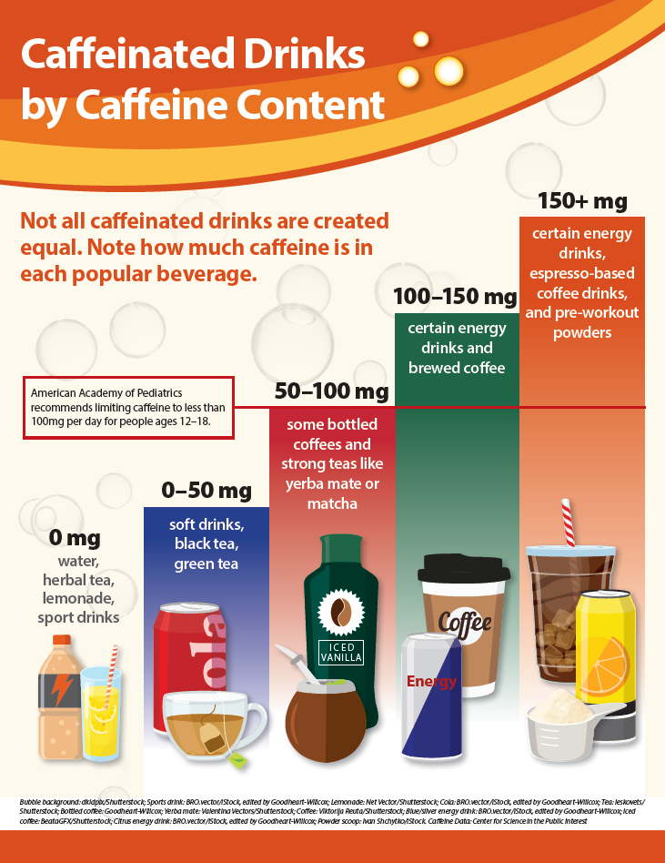
Caffeine has several effects on the body and brain. It triggers the release of the hormone adrenaline. Adrenaline increases heart rate, blood pressure, and oxygen flow. It also triggers the release of the hormone dopamine. Dopamine is known as the “feel-good” hormone. It increases feelings of pleasure and satisfaction.
Caffeine also blocks the release of a chemical known as adenosine. Adenosine slows down the nervous system and makes you feel tired. Caffeine blocking it makes you feel more energized and alert.
In addition to caffeine, energy drinks include other substances. These include sugars, vitamins, and stimulants other than caffeine (for example, taurine). It is important to know that energy drinks are not the same as sports (electrolyte) drinks. Sports drinks do not contain caffeine. They are filled with electrolytes, which are not commonly found in energy drinks. Examples include potassium, magnesium, and B vitamins. Electrolytes help replace the fluids and nutrients you lose during exercise.
Energy drinks can have some short-term benefits. They increase alertness and attention. This is why some teens use energy drinks to stay awake when they feel tired. At the same time, energy drinks have many health risks.

LO 2 What Are the Health Risks of Energy Drinks?
Using energy drinks can lead to serious health conditions. Energy drinks contain high levels of sugar, caffeine, and other stimulants. Large amounts of these substances can disrupt and harm the nervous system and cardiovascular system. They overstimulate the nervous system and increase blood pressure, heart rate, and breathing (Figure 1).

Source: Mattson, M. E. (2013). Update on Emergency Department Visits Involving Energy Drinks: A Continuing Public Health Concern. In The CBHSQ Report. (pp. 1–7). Substance Abuse and Mental Health Services Administration (US).; Photo: Kinstory/Shutterstock.com
Figure 1 Energy drinks can cause health conditions that send teens to the hospital.

People who use energy drinks may experience side effects. These can include:
- Dehydration, or not having enough water in your body
- Heart conditions, such as a fast or abnormal heartbeat
- Anxiety and feeling nervous and jittery
- Difficulty sleeping
- Dental issues, including cavities and tooth decay
- Diarrhea
- Weight gain
Energy drinks can also harm mental health. People can develop dependence on the caffeine in energy drinks. This means their body starts relying on caffeine to function normally. Reducing caffeine use can then lead to headaches, tiredness, and irritability.

LO 3 What Are Safer Alternatives to Energy Drinks?
There are many safe ways to increase energy and alertness. These strategies do not have the health risks of energy drinks.

Drink Lots of Water
Drinking water is one of the best ways to increase energy. Water does not provide energy on its own, but drinking water helps your body’s systems function. Dehydration slows down your body’s systems, meaning nutrients and oxygen take longer to reach your cells. This is why drinking water helps reduce tiredness and increase alertness.
If you do not like the taste of plain water, try sparkling water. You can also create your own flavored water. Try adding a fresh fruit, such as lemon, lime, or strawberry. Try adding a vegetable, such as cucumber. Non-caffeinated tea can also boost energy.

Consider Alternative Drinks
Many beverages other than energy drinks can increase energy without the same health risks (Figure 2). The alternative you choose will depend on your goals. Some drinks, such as caffeinated coffee or tea, provide caffeine. Other drinks, such as sports drinks, help replace the fluids and nutrients you lose during intense exercise. Other options, such as smoothies or protein shakes, add calories.

Top to bottom, left to right: MaraZe/Shutterstock.com, New Africa/Shutterstock.com, New Africa/Shutterstock.com, Soho A Studio/Shutterstock.com, Avocado_studio/Shutterstock.com, mouusastock/Shutterstock.com, LMPark Photos/Shutterstock.com
Figure 2 Safer alternatives to energy drinks.

Eat Regular Meals and Nutritious Snacks
Sometimes people feel tired because they are hungry. Eating regular meals is a good way to maintain your energy.
Eating breakfast is especially important. After not eating all night, your body needs food to provide energy for the day. This is why breakfast is often called the most important meal of the day. Eating a nutritious snack between meals can also boost your energy (Figure 3).
Nutritious Snacks

Left to right: New Africa/Shutterstock.com, Food Impressions/Shutterstock.com, New Africa/Shutterstock.com
Figure 3 Examples of nutritious snacks include whole grains, vegetables, and fruits.
Try to avoid eating simple carbohydrates and sugary snacks to increase energy. These foods can provide a quick energy boost, but this increase is then followed by an energy slump (or sugar crash).

Get Regular Physical Activity
Physical activity is a great way to boost energy and alertness. Being active increases blood flow in the body and helps balance your blood sugar. Physical activity also increases endorphins, chemicals produced by the body that make you feel good.
Find ways to stay active that you enjoy. This could be playing a sport, such as basketball or tennis, or taking a dance class. It could also be going for a run or a brisk walk.

Get Enough Sleep
Many teens do not get enough sleep. This can lead to feelings of tiredness and low energy. One of the best ways to increase your energy is to get enough sleep. Develop a sleep routine. Set a regular time for going to sleep and for waking up.

Talk to a Healthcare Provider
Feeling tired all the time or having little energy can be a sign of a health condition. Talking to a healthcare provider can help you figure out the cause of these symptoms. A healthcare provider can also help you figure out ways to increase energy.

Lesson Review
- Explain how energy drinks are different from sports (electrolyte) drinks. (LO 1)
Answer:
- How do energy drinks affect the cardiovascular system? (LO 2)
Answer:
- What alternatives to energy drinks would be most appropriate for your lifestyle, values, and goals? Why? (LO 3)
Answer:

Name:
Date:
Period:

Student Worksheet

Talking About Energy Drinks
Instructions: In this lesson, you learned about energy drinks. Imagine one of your friends consumes several energy drinks per day. After learning about the risks of using energy drinks, you are very concerned.
- List two to three risks that concern you the most.
Answer:
- What strategies could you use to bring these risks up to your friend? How do you think they might react?
Answer:
- List two to three safer alternatives that you could suggest to your friend.
Answer:
- How might they react to these safer alternatives? Would it help if you also used these safer alternatives?
Answer:
- Talk with a classmate: share the risks that you both listed and the strategies you both would use discussing these risks with your friends.
- Now talk with a different classmate: share the safer alternatives you both listed and the strategies you both would use to discuss these alternatives with your friends.

Answer Key

Lesson Review

Save
Gift Article
Share
- Explain how energy drinks are different from sports (electrolyte) drinks. (LO 1)
Answer: Energy drinks contain large amounts of caffeine and other substances, such as sugar and other stimulants. Sports (electrolyte) drinks do not contain caffeine and usually provide electrolytes to replenish the body after exercise.
- How do energy drinks affect the cardiovascular system? (LO 2)
Answer: Energy drinks contain large amounts of sugar, caffeine, and other stimulants. These increase blood pressure, heart rate, and breathing, which harm the cardiovascular system.
- What alternatives to energy drinks would be most appropriate for your lifestyle, values, and goals? Why? (LO 3)
Answer: Answers will vary, but should analyze alternatives such as drinking water, using alternative drinks, getting physical activity, getting sleep, and talking to a healthcare provider.

