Instructor’s Resource

Lesson to Introduce Oral Nicotine Pouches
This update lesson contains new content to supplement the text’s discussion of the health effects of tobacco products.

Lesson Background
Oral nicotine pouches are mesh sachets or pouches that contain nicotine powder. They are placed beneath the lips or between the cheeks and gums, and nicotine powder is absorbed through the mouth’s moist surfaces into the bloodstream. Among adolescents who use tobacco products, nicotine pouches have become the first choice after vaping devices.
Several factors make oral nicotine pouches attractive to adolescents. The products can be easily concealed and used without other people noticing. Their high nicotine content and appealing flavors attract young people. More than 80 percent of teens who use nicotine pouches use flavored pouches. Teens buy nicotine pouches online, in chain grocery stores, and in some smaller grocery stores.
Nicotine is toxic and addictive, whether it is synthetic or extracted from tobacco. The health effects of nicotine in people are well known. Nicotine use also harms mental and emotional health and can have social and legal consequences. Some nicotine pouches sold today contain much more nicotine than the first pouches on the market. Using this much nicotine increases the risk for short-term and long-term health conditions and for developing nicotine dependence.
Marketing includes misleading and false messages about the safety of nicotine pouches. Consumers should know the FDA has prohibited tobacco companies from calling these products “safe” or “FDA approved.” Students can review and apply their refusal skills to avoid the use of nicotine pouches as well as other tobacco products.

Learning Outcomes
After studying this lesson, students will be able to
- LO 1 describe oral nicotine pouches and their use.
- LO 2 summarize the health effects of using nicotine and nicotine pouches.
- LO 3 analyze how the marketing of nicotine pouches appeals to young people.
- LO 4 demonstrate refusal skills to avoid using nicotine pouches and tobacco products.

National Health Education Standards
The content in this lesson addresses the following National Health Education Standards.
- 2.12.1 Evaluate the interrelationships and impacts of various influences and health behaviors on health and well–being.
- 2.12.4 Formulate strategies to manage influences that impact health and well–being.
- 4.12.5 Apply refusal skills and strategies in a variety of situations.

Key Terms
In this lesson, students will learn the meanings of the following key terms:
- nicotine a toxic substance that gives tobacco products their addictive quality
- nicotine poisoning condition in which someone ingests nicotine faster than the body can process and remove it; can lead to serious symptoms and death
- oral nicotine pouch mesh sachet or pouch containing nicotine, placed beneath a person’s lip or between cheek and gums, where the nicotine is absorbed into their bloodstream

Lesson Materials
- Student Handout: Oral Nicotine Pouches with Lesson Review questions
- Use Your Refusal Skills Infographic
- Student Worksheet: Influences of Advertisement
- Answer Key

Lesson Preparation
- Before introducing students to the lesson, review the Lesson Materials. Distribute the Student Handout: Oral Nicotine Pouches and Student Worksheet: Influences of Advertisement to each of your students. You can print and distribute the Use Your Refusal Skills infographic to students, or you can project the image onto a screen for the class to view.
- Inform students that they will be learning about oral nicotine pouches, which are a popular type of tobacco product.
- Instruct students to read the Student Handout: Oral Nicotine Pouches and answer the Lesson Review questions. (Note: Answers to the Lesson Review questions are located on the Answer Key included with this lesson.)
- Open a discussion about oral nicotine pouches. Answer any questions students may have.
- Instruct students to complete the Student Worksheet: Influences of Advertisement. This activity helps students analyze influences and advocate for health.
- Close the lesson by reinforcing the learning outcomes and the health effects of using oral nicotine pouches.

List of Sources
American Lung Association. (2025). Emerging Commercial Tobacco and Nicotine Products. https://www.lung.org/quit-smoking/smoking-facts/health-effects/emerging-products
American Lung Association. (2025). 9 of the Strategies Big Tobacco Uses to Target Kids. https://www.lung.org/research/sotc/by-the-numbers/8-things-industry-ecigs
Chowdhury, A. and Gill, N. (2025). FDA Issues First Marketing Authorization for Oral Nicotine Pouches. The National Law Review. Volume XV, Number 240. August 28. https://natlawreview.com/article/fda-issues-first-marketing-authorization-oral-nicotine-pouches
Cleveland Clinic (2025). Nicotine Poisoning. https://my.clevelandclinic.org/health/diseases/21582-nicotine-poisoning
Czaplicki, L., Patel, M., Rahman, B., et al. (2022). Oral Nicotine Marketing Claims in Direct-Mail Advertising. Tobacco Control, 31(5), 663–666. DOI: https://doi.org/10.1136/tobaccocontrol-2020-056446
Delnevo CD, Hrywna M, Miller Lo EJ, et al. Examining Market Trends in Smokeless Tobacco Sales in the United States: 2011-2019. Nicotine Tob Res 2021;23:1420–4. DOI: https://doi.org/10.1093/ntr/ntaa239
Emery SL, Binns S, Carter CC, et al. (2023). Characterising Advertising Strategies and Expenditures for Conventional and Newer Smokeless Tobacco Products. Tobacco Control; 32:795-798. DOI: https://doi.org/10.1136/tobaccocontrol-2022-057282
Felicione, N. J., Ozga, J. E., Eversole, A., et al. (2025). Oral Nicotine Pouches: Rising Popularity and State of the Science. Public Health Reports; advance online publication. https://doi.org/10.1177/00333549251313668
Food and Drug Administration. FDA Authorizes Marketing of 20 ZYN Nicotine Pouch Products after Extensive Scientific Review. Press Release. January 16, 2025. https://www.fda.gov/news-events/press-announcements/fda-authorizes-marketing-20-zyn-nicotine-pouch-products-after-extensive-scientific-review
Yale Medicine. (2025). What Parents Should Know About Nicotine Pouches. https://www.yalemedicine.org/news/nicotine-pouches

Student Handout
Oral Nicotine Pouches

Learning Outcomes
After studying this lesson, you will be able to
- LO 1 describe oral nicotine pouches and their use.
- LO 2 summarize the health effects of using nicotine and nicotine pouches.
- LO 3 analyze how the marketing of nicotine pouches appeals to young people.
- LO 4 demonstrate refusal skills to avoid using nicotine pouches and tobacco products.

Key Terms
- nicotine a toxic substance that gives tobacco products their addictive quality
- nicotine poisoning condition in which someone ingests nicotine faster than the body can process and remove it; can lead to serious symptoms and death
- oral nicotine pouch mesh sachet or pouch containing nicotine, placed beneath a person’s lip or between cheek and gums, where the nicotine is absorbed into their bloodstream

LO 1 What Are Oral Nicotine Pouches?
A tobacco product is any product made or derived from tobacco and intended for human consumption. Tobacco products may contain parts of the tobacco plant or synthetic nicotine. Nicotine is the toxic substance that makes tobacco products addictive. Some types of tobacco products, such as cigarettes and vaping devices, are smoked or vaped. Other tobacco products, like smokeless tobacco, are not smoked or vaped.
When you think of smokeless tobacco, you might think of chewing tobacco or snus. Another tobacco product that is growing in popularity and may harm health is oral nicotine pouches. Oral nicotine pouches are small mesh sachets or pouches filled with nicotine powder. Unlike smokeless tobacco products, these pouches do not contain tobacco leaves.
Nicotine pouches come in different sizes and flavors and have different amounts of nicotine. They are commonly sold in tins of 15 to 20 pouches (Figure 1).
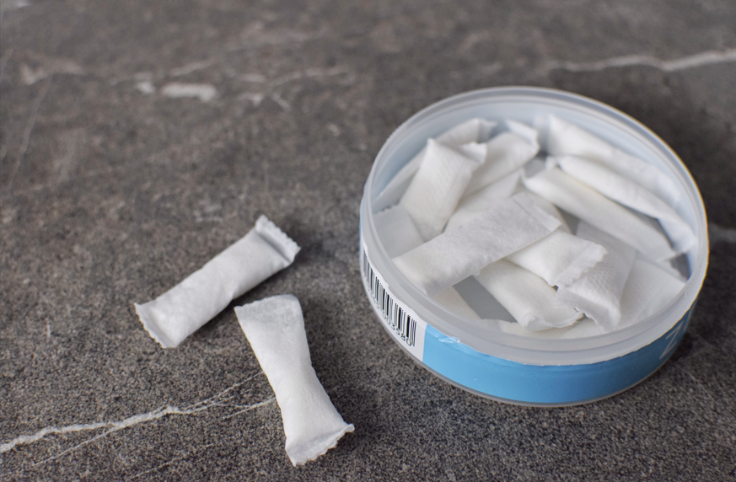
Natalia Bohren/Shutterstock.com
Figure 1 Nicotine pouches are often sold in tins.
Nicotine pouches are not intended to be burned or heated. Instead, a person places the pouch beneath their lips or between their cheeks and gums. Nicotine powder is absorbed through the mouth’s moist surfaces into the bloodstream. Nicotine may also be absorbed when saliva containing nicotine is swallowed. A person uses the pouch for 15 to 45 minutes, depending on its size and nicotine content. When finished, the pouch is discarded.
Other people may not notice someone is using a nicotine pouch. Unlike with chewing tobacco, a person using a nicotine pouch does not need to spit.
Today, students who use tobacco products say nicotine pouches are their first choice after vaping devices. About 480,000 students use these addictive and toxic products. The National Youth Tobacco Survey found that some adolescents use nicotine pouches regularly. This exposes adolescents to high levels of nicotine over extended periods. Among adolescents who use nicotine pouches, more than two in 10 use them daily. More than one in four have used them on at least 20 of the last 30 days.

LO 2 Using Nicotine Pouches Harms Health
Regardless of whether it is smoked, vaped, or consumed in an oral pouch, nicotine can harm mental health. Using nicotine can also have social and legal effects (Figure 2).

Goodheart-Willcox Publisher
Figure 2 Using nicotine can harm multiple dimensions of health.
Using nicotine in any form has significant effects on physical health. The first nicotine pouches approved for marketing contained 3 mg or 6 mg of nicotine. Consuming even these quantities harms health and can lead to nicotine addiction. Other companies now sell pouches containing as much as 12 mg or 20 mg of nicotine.
Using nicotine pouches exposes adolescents to high levels of nicotine. The American Lung Association reports people who use nicotine pouches use 8–10 pouches per day. For a pouch containing 6 mg nicotine, a person using 10 pouches per day will consume as much nicotine as smoking 1 1/2 packs of cigarettes. Nicotine can be detected in the blood three days after use. A person may ingest nicotine faster than the body can process and remove it.
In rare cases, a person can take in enough nicotine to experience symptoms of nicotine poisoning. Though rare in adults, nicotine poisoning is more common in people with lower body weights. Children, young adolescents, and small adults are more susceptible.
Early signs of nicotine poisoning can happen 15–30 minutes after ingesting a poisonous amount. Signs and symptoms include vomiting, increased salivation, abdominal pain, and sweating. Nicotine's effects on the heart and lungs lead to high heart rate, low blood pressure, and rapid, shallow breathing. The effect on the nervous system leads to headaches, dizziness, tremors, seizures, loss of muscle control, and inability to walk. Nicotine poisoning can be treated by medical professionals to prevent the condition from worsening. Ingesting about 25–30 mg of nicotine per pound of body weight can cause death in an adult.
Nicotine causes inflammation to the surfaces of the gums, mouth, and throat. Inflammation can cause sores, injure cells, and over time raise the risk for developing cancers, such as oral cancer or throat cancer. Nicotine use dries the mouth and may lead to gum disease.
In addition to these, adolescents who use nicotine pouches risk the short-term and long-term health conditions in Figure 3.

Goodheart-Willcox Publisher; Photo: Gera Photo/Shutterstock.com
Figure 3 However nicotine is consumed, it affects multiple body systems.

LO 3 Marketing Appeals to Adolescents
In January 2025, the Food and Drug Administration (FDA) approved a tobacco company to market 20 kinds of nicotine pouches. These included pouches made with 3 mg or 6 mg of nicotine and 10 flavors. Marketing was restricted to adults ages 21 and older. The FDA prohibited the tobacco company from calling nicotine pouches “safe” or “FDA approved.”
Tobacco companies have focused on advertising nicotine pouches. They once spent 25 percent of their marketing budget on these pouches. In the years leading up to FDA marketing approval, they began spending 90 percent of that budget on advertising nicotine pouches.
Advertisements for nicotine pouches reach consumers many ways. Advertising has been permitted on TV and radio because nicotine pouches do not contain tobacco. Advertising reaches consumers by mail and online.
Marketing may make these products attractive to young people by telling consumers that nicotine pouches:
- contain high nicotine content
- contain no tobacco
- are available with flavors other than tobacco
- include appealing flavors, such as mint, fruit, menthol, desserts, and candies
- are easily concealed and convenient
- are associated with masculinity, freedom, and adventure
On top of these marketing strategies, tobacco companies make false and misleading claims about the safety of using nicotine pouches. This has resulted in myths about nicotine pouches (Figure 4).
Myths | Facts
Using pouches is safe because they do not contain tobacco. | Nicotine is addictive and toxic, even in the absence of tobacco.
Using pouches is safe because they are not burned or heated. | Nicotine in oral pouches is still absorbed into the body and is toxic and addictive.
Synthetic nicotine is safer to use than nicotine extracted from tobacco. | Synthetic nicotine is the same chemical as nicotine extracted from tobacco. Synthetic nicotine has the same effects on the body.
Pouches made with synthetic nicotine do not contain toxic chemicals found in tobacco. | Lab tests have found toxins such as formaldehyde, ammonia, chromium, and nickel in pouches made with synthetic nicotine.
Pouches are safe and approved by the FDA. | The FDA prohibits tobacco companies from calling nicotine pouches “safe” or “FDA approved.”
Using nicotine pouches reduces smoking. | The FDA has not approved the sale of any brand of oral nicotine pouch as safe or effective for quitting smoking.
Goodheart-Willcox Publisher
Figure 4 Tobacco companies may spread myths about nicotine pouches in their advertising.

LO 4 Review and Use Your Refusal Skills
You can use your refusal skills to avoid the harmful effects of nicotine pouches and other tobacco products. Prepare by practicing what you will say and do if someone pressures you to try these products. It will be easier for you to respond if you are ready ahead of time.
Remember these refusal tips:
- Speak assertively: Speak clearly and confidently. Use confident body language, like keeping your head up and maintaining eye contact.
- Know what you would say or do: You can say no, share your reasons for saying no, or emphasize the health risks. You can also provide an alternative activity instead of using tobacco products.
- Remove yourself from the situation: Act in a way that will get you out of the situation. This could mean walking away or changing the subject.

Lesson Review
- Explain the difference between nicotine pouches and vaping devices. What do both products contain? (LO 1)
Answer:
- How does nicotine use increase risk for oral and throat cancer? (LO 2)
Answer:
- List one myth about nicotine pouches, then state a fact that corrects it. (LO 3)
Answer:
- Give one example of a refusal skill that has been effective for you. Why was it effective? (LO 4)
Answer:

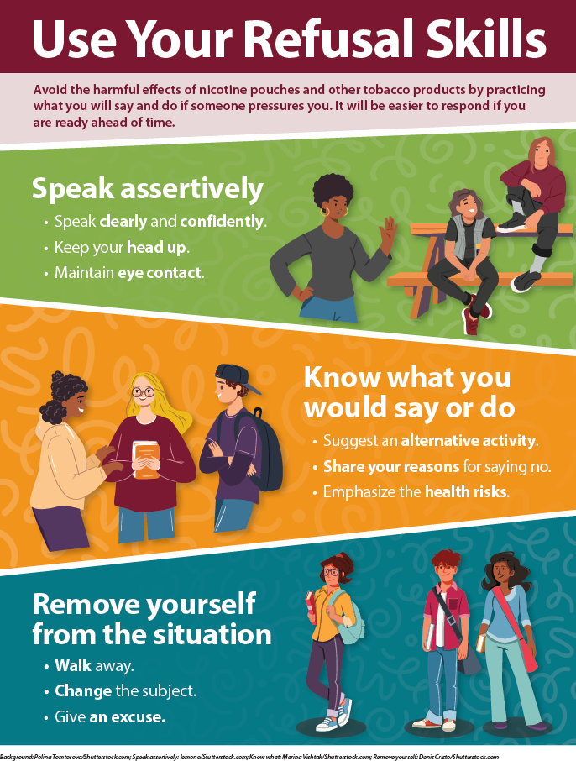

Student Worksheet

Influences of Advertisement

Part 1: Analyze Influences
Instructions: Advertisements have made oral nicotine pouches more popular. You might encounter these advertisements online, on TV, in podcasts, or in your surroundings. In the table that follows, list two ways these advertisements have influenced you. Analyze how effectively these strategies influenced your decisions about using these products.
How have advertisements influenced you? | How effective were they?
Influence: | Effectiveness:
Influence: | Effectiveness:

Part 2: Advocate for Health
Instructions: Using the information in this lesson, as well as any additional information from credible sources, write or design your own advertisement about the health effects of using nicotine and nicotine pouches. Your advertisement can take any form. For example, it could be an infographic, social media post, or script for a streaming service ad. Submit the advertisement to your teacher and then answer the questions that follow.
- How would your message influence health and wellness?
Answer:
- Compare the impact of your message to the impact of an advertisement from a tobacco company. How are the impacts different?
Answer:

Answer Key

Lesson Review
- Explain the difference between nicotine pouches and vaping devices. What do both products contain? (LO 1)
Answer: Vaping devices are vaped. The nicotine is heated and then inhaled. Nicotine pouches are not smoked or vaped. They introduce nicotine through the mouth's surfaces. Both products contain nicotine.
- How does nicotine use increase risk for oral and throat cancer? (LO 2)
Answer: Nicotine causes inflammation to the surfaces of the gums, mouth, and throat. Inflammation can raise the risk for developing cancers.
- List one myth about nicotine pouches, then state a fact that corrects it. (LO 3)
Answer: See Figure 4 for a list of myths and facts.
- Give one example of a refusal skill that has been effective for you. Why was it effective? (LO 4)
Answer: Answers will vary, but should reflect knowledge of refusal skills and the ability to apply them.

