Instructor’s Resource

Lesson to Introduce Energy Drinks
This lesson contains new content to supplement the text’s discussion of caffeine. This lesson will describe what energy drinks are, the health risks of energy drinks, and safer alternatives to energy drinks.

Lesson Background
Some young people use energy drinks to boost their energy. Energy drinks contain large amounts of caffeine, a substance that increases energy and alertness. Energy drinks also include sugars, vitamins, and other stimulants (substances that increase activity in the nervous system).
Caffeine triggers the release of various hormones, including adrenaline and dopamine. These hormones increase heart rate, blood pressure, oxygen flow, and feelings of pleasure and satisfaction. Caffeine also blocks the effects of adenosine. Adenosine slows down the nervous system and makes you feel tired.
Energy drinks are not the same as sports (electrolyte) drinks. Sports drinks do not contain caffeine. They do contain electrolytes, such as potassium, magnesium, and B vitamins. These substances help replace the fluids and nutrients you lose during exercise.
Energy drinks can increase alertness and attention. This is why some young people use energy drinks to stay awake when they feel tired. They can, however, lead to serious health conditions. Energy drinks contain high levels of sugar, caffeine, and other stimulants that can harm the nervous system. They increase blood pressure, heart rate, and breathing. Side effects of energy drinks can include: dehydration (not having enough water in your body), heart conditions (including a too fast or abnormal heartbeat), anxiety and nervousness, difficulty sleeping, dental issues (cavities and tooth decay), diarrhea, and weight gain. More than 1,000 teens every year go to the hospital following use of an energy drink.
Energy drinks can also harm mental health. People can develop a dependence on the caffeine. This means their body starts relying on caffeine to function normally. Reducing caffeine use can then lead to headaches, tiredness, and irritability.
There are many safe alternatives to increase energy and alertness. Drinking water is one of the best ways to increase energy. Sparkling water, flavored water, and non-caffeinated tea are all good alternatives. Other safer drinks include smoothies, caffeinated coffee or tea, milk, protein shakes, fruit juice, and sports (electrolyte) drinks. Other strategies include eating regular meals and nutritious snacks, getting enough sleep, and getting regular physical activity.
Feeling tired all the time or lacking energy can be a sign of a health condition. Talking to a healthcare provider can help you figure out the cause of these symptoms.

Learning Outcomes
After studying this lesson, you will be able to
- LO 1 Understand what caffeine is.
- LO 2 Explain what energy drinks are.
- LO 3 Analyze the health risks of using energy drinks.
- LO 4 Identify safer alternatives to energy drinks.

National Health Education Standards
The content in this lesson addresses the following National Health Education Standards.
- 1.8.3 Analyze behaviors that reduce or prevent illnesses and injuries.
- 1.8.4 Analyze practices and behaviors that support health and well-being, including how to manage health conditions.
- 3.8.4 Analyze the validity, reliability, and accessibility of health information, products, services, and other resources.
- 5.8.4 Evaluate how various options may affect health-related outcomes at individual, interpersonal, community, societal, and environmental levels.
- 7.8.2 Analyze practices and behaviors that support personal and community health and well-being.

Key Terms
In this lesson, students will learn the meanings of the following key terms:
caffeine a stimulant that increases feelings of energy and alertness
dehydration not having enough water in the body
endorphins chemicals produced by the body that make you feel good
energy drinks beverages that contain high levels of caffeine, sugar, and other stimulants designed to boost energy and alertness
sports (electrolyte) drinks beverages that contain water, electrolytes (such as sodium, potassium, and magnesium), and potentially sugar
stimulant a substance that increases activity in the nervous system

Lesson Materials
- Student Handout: Energy Drinks with Lesson Review questions
- Flavored Beverages Infographic
- Student Worksheet: Making Decisions About Energy Drinks
- Answer Key

Lesson Preparation
- Before introducing students to the lesson, review the Lesson Materials. Distribute the Student Handout: Energy Drinks and Student Worksheet: Making Decisions About Energy Drinks to each of your students. You can print and distribute the Flavored Beverages infographic to students, or you can project the image onto a screen for the class to view.
- Inform students that they will be learning about energy drinks, which are a popular source of caffeine.
- Instruct students to read the Student Handout: Energy Drinks and answer the Lesson Review questions. (Note: Answers to the Lesson Review questions are located on the Answer Key included with this lesson.)
- Open a discussion about energy drinks. Answer any questions students may have.
- Instruct students to complete the Student Worksheet: Making Decisions About Energy Drinks. This activity helps students make decisions that support their health.
- Close the lesson by reinforcing the learning outcomes and the health effects of energy drinks.

List of Sources
Centers for Disease Control and Prevention. (2024, July 22). The buzz on energy drinks. https://www.cdc.gov/school-nutrition/energy-drinks/index.html
Costantino, A., Maiese, A., Lazzari, J., Casula, C., Turillazzi, E., Frati, P., & Fineschi, V. (2023). The dark side of energy drinks: A comprehensive review of their impact on the human body. Nutrients, 15(18), 3922. https://doi.org/10.3390/nu15183922
Miller, K. E., Dermen, K. H., & Lucke, J. F. (2018). Caffeinated energy drink use by U.S. adolescents aged 13–17: A national profile. Psychology of Addictive Behaviors, 32(6), 647–659. https://doi.org/10.1037/adb0000389
Moawad, H. (2025, September 10). Understanding the health impacts of energy drinks: What you need to know. Verywell Health. https://www.verywellhealth.com/are-energy-drinks-bad-for-you-11805426
Nazish, N. (2025, September 11). What happens to your mental health when you consume energy drinks regularly. Verywell Mind. https://www.verywellmind.com/what-happens-when-you-consume-energy-drinks-regularly-11808532
Richards, G., & Smith, A. P. (2016). A review of energy drinks and mental health, with a focus on stress, anxiety, and depression. Journal of Caffeine Research, 6(2), 49–63. https://doi.org/10.1089/jcr.2015.0033
Ruiz, L. D., & Scherr, R. E. (2018). Risk of energy drink consumption to adolescent health. American Journal of Lifestyle Medicine, 13(1), 22–25. https://doi.org/10.1177/1559827618803069

Student Handout
Energy Drinks

Learning Outcomes
After studying this lesson, you will be able to
- LO 1 Understand what caffeine is.
- LO 2 Explain what energy drinks are.
- LO 3 Analyze the health risks of using energy drinks.
- LO 4 Identify safer alternatives to energy drinks.

Key Terms
caffeine a stimulant that increases energy and alertness
dehydration not having enough water in the body
endorphins chemicals produced by the body that make you feel good
energy drinks beverages that contain high levels of caffeine, sugar, and other stimulants designed to boost energy and alertness
sports (electrolyte) drinks beverages that contain water, electrolytes (such as sodium, potassium, and magnesium), and potentially sugar
stimulant a substance that increases activity in the nervous system

LO 1 What Is Caffeine?
Life can be full of activity — from school to extracurricular clubs to time with family and friends. Add homework and early school mornings to that, and young people may feel like they do not have the energy for everything in a day. Some people may turn to caffeine to boost their energy levels.
Caffeine is a substance that increases energy and alertness. It is a stimulant, which is a substance that increases activity in the nervous system. Caffeine is found in many different foods and drinks. These include coffee, certain teas and soft drinks, energy drinks, caffeinated snacks, and chocolate.
Caffeine has several effects on the body and brain.
- Caffeine triggers the release of a hormone that increases heart rate, blood pressure, and oxygen flow.
- Caffeine triggers the release of a hormone that increases feelings of pleasure and satisfaction.
- Caffeine also blocks the release of a chemical that slows down the nervous system and makes you feel tired.
These effects of caffeine lead people to feel more energized and alert, and less tired. Caffeine can also boost mood and increase focus. These effects help explain why caffeine is the most commonly used drug in the world.

LO 2 What Are Energy Drinks?
Some young people use energy drinks to boost their energy. Energy drinks are beverages that contain large amounts of caffeine. Energy drinks have about as much caffeine as in a cup of coffee. They have much more caffeine than soda, tea, or flavored water (Figure 1).
How Much Caffeine Is in My Drink?

Source: Center for Science in the Public Interest
Figure 1 Caffeinated drinks by caffeine content, based on 12-ounce servings.
In addition to caffeine, energy drinks include other substances. These substances include sugars, vitamins, and other stimulants.
Energy drinks are not the same as sports (electrolyte) drinks. Sports drinks do not contain caffeine. They are filled with electrolytes, which are not commonly found in energy drinks. Examples of electrolytes include potassium, magnesium, and B vitamins. Electrolytes can help replace the fluids and nutrients you lose during exercise.
Energy drinks can have some short-term benefits. They increase alertness and attention. This is why some young people use energy drinks to help them stay awake when they feel tired. At the same time, energy drinks have many health risks.

LO 3 What Are the Health Risks of Energy Drinks?
Using energy drinks can lead to serious health conditions. Energy drinks contain high levels of sugar, caffeine, and other stimulants. Large amounts of these substances can harm the nervous and cardiovascular body systems. They increase blood pressure, heart rate, and breathing. More than 1,000 teens every year go to the hospital following use of an energy drink.
People who use energy drinks may experience side effects. These can include heart conditions, such as a fast or abnormal heartbeat, anxiety and feeling nervous and jittery, diarrhea, and weight gain.
Energy drinks can also lead to trouble falling and staying asleep. On average, it takes your body five or six hours to use just half of the caffeine you consume. This means that drinking caffeine later in the day could keep you awake well into the evening.
Not getting enough sleep makes you feel tired the next day. This can increase the desire to use energy drinks. This effect sets up a difficult cycle to break (Figure 2).

Sakorn saenudon/Shutterstock.com; Goodheart-Willcox Publisher
Figure 2 Because energy drinks make it harder to get quality sleep at night, they can cause people to rely on caffeine day after day.
One of the most serious side effects of energy drinks is dehydration, or not having enough water in your body. The high levels of caffeine and sugar in energy drinks lead to your kidneys removing more water from your body. Drinking energy drinks therefore causes more dehydration than simply not drinking water.
Energy drinks can cause dental conditions. These drinks are high in sugar. They also contain flavorings that are high in acid. These sugars and acids damage tooth enamel. Over time, this causes tooth decay, sensitivity, and cavities.
A person’s mental health can also be impacted by energy drinks. People can become dependent on the caffeine in energy drinks. This means their body starts relying on caffeine to function as usual. Not consuming caffeine can then lead to headaches, tiredness, and irritability.

LO 4 What Are Safer Alternatives to Energy Drinks?
The American Academy of Pediatrics recommends that people aged 12 to 18 consume less than 100mg of caffeine per day. Beverages like energy drinks, coffee, and espresso are often over these limits. However, there are many safe ways to increase energy and alertness. These strategies do not have the health risks of energy drinks.

Drink Lots of Water
Drinking water is one of the best ways to increase energy. Water does not provide energy on its own, but drinking water helps your body’s systems function. Dehydration slows down your body’s systems, meaning nutrients and oxygen take longer to reach your cells. This is why drinking water helps reduce tiredness and increase alertness.
If you do not like the taste of plain water, mix it up (Figure 3). Non-caffeinated tea can also help boost energy.

yrabota/istock/Getty Images Plus via Getty Images
Figure 3 Adding fresh flavors to your water can make it more enjoyable to drink.

Consider Alternative Drinks
Many beverages other than energy drinks can increase energy without the same health risks. Some of these drinks include:
- Smoothies, which can include vegetables, fruit, and/or dairy products
- Regular caffeinated coffee (not espresso) or decaffeinated coffee
- Caffeinated tea
- Dairy or nondairy milk
- Protein shakes
- Fruit juice
- Sport (electrolyte) drinks
The alternative you choose will depend on your goals. Some drinks, such as caffeinated coffee or tea, provide caffeine. Other drinks, such as sport drinks, help replace the fluids and nutrients you lose during intense exercise. Other options, such as smoothies or protein shakes, add calories.

Eat Regular Meals and Nutritious Snacks
Sometimes people feel tired because they are hungry. Eating regular meals is a good way to maintain your energy.
Eating breakfast is especially important. After not eating all night, your body needs food to provide energy for the day. This is why breakfast is often called the most important meal of the day.
Eating a nutritious snack between meals can also boost your energy (Figure 4). Try to avoid eating simple carbohydrates and sugary snacks to increase energy. These foods can provide a quick energy boost, but this increase is then followed by an energy slump (or sugar crash).

Sokor Space/Shutterstock.com; Brent Hofacker/Shutterstock.com; sofeiganita/Shutterstock.com
Figure 4 Healthy snacks include whole grains, vegetables, and fruits.

Get Regular Physical Activity
Physical activity is a great way to boost energy and alertness. Being active increases blood flow in the body and helps balance your blood sugar. Physical activity also increases endorphins, chemicals produced by the body that make you feel good.
Find ways to stay active that you enjoy. This could be playing a sport, such as basketball or tennis, or taking a dance class. It could also be going for a run or a brisk walk.

Get Enough Sleep
Many young people do not get enough sleep. This can lead to feelings of tiredness and low energy. One of the best ways to increase your energy is to get enough sleep. Develop a sleep routine. Set a regular time for going to sleep and for waking up.

Talk to a Healthcare Provider
Feeling tired all the time or having little energy can be a sign of a health condition. Talking to a healthcare provider can help you figure out the cause of these symptoms. A healthcare provider can also help you figure out ways to increase energy.

Lesson Review
- What kind of substance increases activity in the nervous system? (LO 1)

  - Stimulant
  - Sugar
  - Electrolyte
  - Endorphin

Answer:
- True or false. Energy drinks are a type of sports (electrolyte) drink. (LO 2)
Answer:
- Drinking energy drinks can cause __________, a health condition where a person does not have enough water in their body. (LO 3)
Answer:
- What chemical released by physical activity makes a person feel good? (LO 4)
Answer:
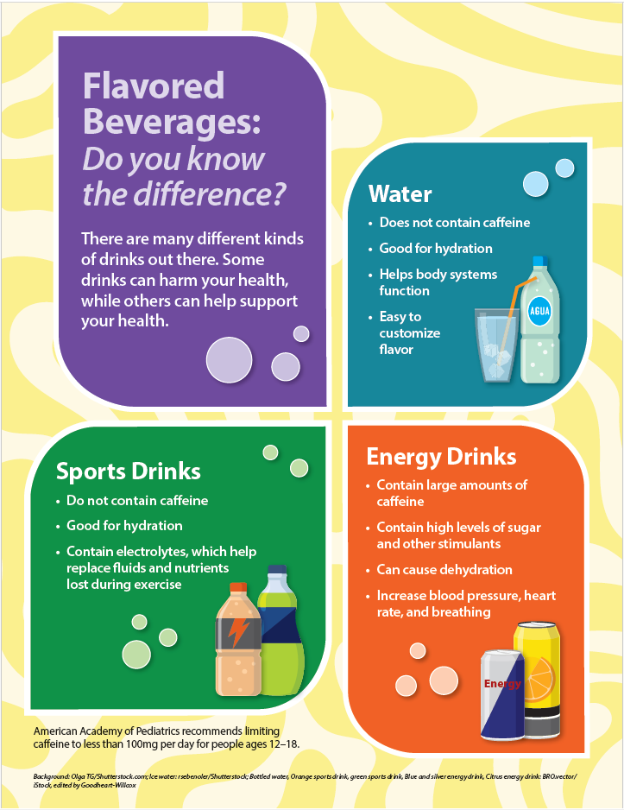
Name:
Date:
Period:

Student Worksheet

Making Decisions About Energy Drinks
Directions: Read the scenario and guide Leo through the decision-making process to make the choice that will best support his health.

Scenario
13-year-old Leo is at a "gaming marathon" sleepover with three friends. They all brought their own devices and have a great set-up in the basement with screens, snacks, and music. Leo and his friends have been gaming for four hours. Leo is exhausted, but his friends seem wide awake. Leo’s eyes are stinging, and his reaction time in the game is slowing down.
Leo is the only one in the group who hasn't had a "Volt-Max" energy drink—a brand trending because of its neon-colored cans and claims of "limitless focus." Leo’s friend, Jax, gives Leo a can and says, "Drink up, Leo. If you crash now, we’re going to lose our ranking. It’s just caffeine, so it’s basically soda."
Leo remembers his coach saying that energy drinks can mess with your hydration and sleep. He has a soccer game tomorrow morning, but he doesn't want to be the "boring" friend who falls asleep and ruins the winning streak. He feels nervous about the energy drink, but Jax and the others are already cracking open their second cans, laughing and shouting at the screen, ready for many more hours of gaming.

Decision-Making Process
- Identify the Decision or Problem. Think carefully about the situation to define the decision Leo needs to make.
Answer:
- Brainstorm and Evaluate Options. Make a list of Leo’s options. Identify the best- and worst-case scenarios of each option. Consider the impact of each option on Leo’s health. Note: Four rows are provided in the chart, but use as many as you need.
Options | Best-Case Scenario (Pros) | Worst-Case Scenario (Cons) | Impacts on Health
Option #1: | Pros: | Cons: | Impacts:
Option #2: | Pros: | Cons: | Impacts:
Option #3: | Pros: | Cons: | Impacts:
Option #4: | Pros: | Cons: | Impacts:
- Make a Decision. Based on your evaluation of each option, which decision should Leo make? Defend your answer. Describe how Leo would carry out the decision.
Answer:

Answer Key

Lesson Review
- What kind of substance increases activity in the nervous system? (LO 1)

  - Stimulant
  - Sugar
  - Electrolyte
  - Endorphin

Answer: A: Stimulant
- True or false. Energy drinks are a type of sports (electrolyte) drink. (LO 2)
Answer: False.
- Drinking energy drinks can cause __________, a health condition where a person does not have enough water in their body. (LO 3)
Answer: dehydration
- What chemical released by physical activity makes a person feel good? (LO 4)
Answer: endorphins

Student Worksheet
Student answers will vary. A sample response is shown.
- Leo needs to decide whether to drink the energy drink.
- Leo’s options:
Options | Best-Case Scenario (Pros) | Worst-Case Scenario (Cons) | Impacts on Health
Option #1: Drink the energy drink. | Pros: Able to play games with friends all night (social acceptance) | Cons: Does not sleep well, feels tired at soccer game, does not perform well | Impacts: Lack of sleep, may feel anxiety, poor athletic performance
Option #2: Do not drink the energy drink. | Pros: Sleeps well through the night, feels fresh for soccer game | Cons: Plays poorly at game, falls asleep earlier than friends (social exclusion) | Impacts: Good sleep, good athletic performance, feeling disconnected from friends
- Student decisions will vary. Ideally, students identify not drinking the energy drink as the preferred option from a physical health standpoint, and as a teammate in a soccer game. However, middle school students may identify that social acceptance among friends is extremely important and therefore they may value that over physical well-being at this point in their life. All points are valid and should result in conversation between students and teachers about the pros and cons of every decision. It is important for teachers to ensure validation while also stressing the health consequences of energy drinks. Teachers should consider extending this activity to discuss other alternative options (i.e. Leo drinks/eats something else, Leo attempts to convince friends not to drink anymore) and potential outcomes.

