Instructor’s Resource

Lesson to Introduce Oral Nicotine Pouches
This update lesson contains new content to supplement the text’s discussion of the health effects of tobacco products.

Lesson Background
Oral nicotine pouches are mesh sachets or pouches that contain nicotine powder. They are placed beneath the lips or between the cheeks and gums, and nicotine powder is absorbed through the mouth’s moist surfaces into the bloodstream. Among adolescents who use tobacco products, nicotine pouches have become the first choice after vaping devices.
Several factors make oral nicotine pouches attractive to adolescents. The products can be easily concealed and used without other people noticing. Their high nicotine content and appealing flavors attract young people. More than 80 percent of teens who use nicotine pouches use flavored pouches. Teens buy nicotine pouches online, in chain grocery stores, and in some smaller grocery stores.
Nicotine is toxic and addictive, whether it is synthetic or extracted from tobacco. The health effects of nicotine in people are well known. Nicotine use also harms mental and emotional health, and can have social and legal consequences. Some nicotine pouches sold today contain much more nicotine than the first pouches on the market. Using this much nicotine increases the risk for short-term and long-term health conditions, and for developing nicotine dependence.
Marketing includes misleading and false messages about the safety of nicotine pouches. Consumers should know the FDA has prohibited tobacco companies from calling these products “safe” or “FDA approved.” Students can review and apply their refusal skills to avoid the use of nicotine pouches and other tobacco products.

Learning Outcomes
After studying this lesson, students will be able to
- LO 1 Describe oral nicotine pouches and their use.
- LO 2 Summarize the health effects of using nicotine and nicotine pouches.
- LO 3 Analyze how the marketing of nicotine pouches appeals to young people.
- LO 4 Demonstrate refusal skills to avoid using nicotine pouches and tobacco products.

National Health Education Standards
The content in this lesson addresses the following National Health Education Standards.
- 1.8.3 Analyze behaviors that reduce or prevent illnesses and injuries.
- 2.8.4 Apply strategies and resources to manage influences that impact health and well-being
- 4.8.5 Use refusal skills and strategies in a variety of situations.

Key Terms
In this lesson, students will learn the meanings of the following key terms:
- nicotine a toxic substance that gives tobacco products their addictive quality.
- oral nicotine pouch mesh sachet or pouch containing nicotine, placed beneath a person’s lip or between cheek and gums, where the nicotine is absorbed into their bloodstream.

Lesson Materials
- Student Handout: Oral Nicotine Pouches with Lesson Review questions
- Cigarettes Versus Nicotine Pouches Infographic
- Student Worksheet: Responding Respectfully and Assertively
- Answer Key

Lesson Preparation
- Before introducing students to the lesson, review the Lesson Materials. Distribute the Student Handout: Oral Nicotine Pouches and Student Worksheet: Responding Respectfully and Assertively to each of your students. You can print and distribute the Cigarettes Versus Nicotine Pouches infographic to students, or you can project the image onto a screen for the class to view.
- Inform students that they will be learning about oral nicotine pouches, which are a popular type of tobacco product.
- Instruct students to read the Student Handout: Oral Nicotine Pouches and answer the Lesson Review questions. (Note: Answers to the Lesson Review questions are located on the Answer Key included with this lesson.)
- Open a discussion about oral nicotine pouches. Answer any questions students may have.
- Instruct students to complete the Student Worksheet: Responding Respectfully and Assertively. This activity helps students work on their communication and refusal skills.
- Close the lesson by reinforcing the learning outcomes and the health effects of using oral nicotine pouches.

List of Sources
American Lung Association. (2025). Emerging Commercial Tobacco and Nicotine Products. https://www.lung.org/quit-smoking/smoking-facts/health-effects/emerging-products
American Lung Association. (2025). 9 of the Strategies Big Tobacco Uses to Target Kids. https://www.lung.org/research/sotc/by-the-numbers/8-things-industry-ecigs
Chowdhury, A. and Gill, N. (2025). FDA Issues First Marketing Authorization for Oral Nicotine Pouches. The National Law Review. Volume XV, Number 240. August 28. https://natlawreview.com/article/fda-issues-first-marketing-authorization-oral-nicotine-pouches
sCzaplicki, L., Patel, M., Rahman, B., et al. (2022). Oral Nicotine Marketing Claims in Direct-Mail Advertising. Tobacco Control, 31(5), 663–666. DOI: https://doi.org/10.1136/tobaccocontrol-2020-056446
Delnevo CD, Hrywna M, Miller Lo EJ, et al. Examining Market Trends in Smokeless
Tobacco Sales in the United States: 2011-2019. Nicotine Tob Res 2021;23:1420–4. DOI: https://doi.org/10.1093/ntr/ntaa239
Emery SL, Binns S, Carter CC, et al. (2023). Characterising Advertising Strategies and Expenditures for Conventional and Newer Smokeless Tobacco Products. Tobacco Control; 32:795-798. DOI: https://doi.org/10.1136/tobaccocontrol-2022-057282
Felicione, N. J., Ozga, J. E., Eversole, A., et al. (2025). Oral Nicotine Pouches: Rising Popularity and State of the Science. Public Health Reports; advance online publication. https://doi.org/10.1177/00333549251313668
Food and Drug Administration. FDA Authorizes Marketing of 20 ZYN Nicotine Pouch Products after Extensive Scientific Review. Press Release. January 16, 2025. https://www.fda.gov/news-events/press-announcements/fda-authorizes-marketing-20-zyn-nicotine-pouch-products-after-extensive-scientific-review
Yale Medicine. (2025). What Parents Should Know About Nicotine Pouches. https://www.yalemedicine.org/news/nicotine-pouches
Student Handout
Oral Nicotine Pouches

Learning Outcomes
After studying this lesson, you will be able to
- LO 1 Describe oral nicotine pouches and their use.
- LO 2 Summarize the health effects of using nicotine and nicotine pouches.
- LO 3 Analyze how the marketing of nicotine pouches appeals to young people.
- LO 4 Demonstrate refusal skills to avoid using nicotine pouches and tobacco products.

Key Terms
- nicotine a toxic substance that gives tobacco products their addictive quality.
- oral nicotine pouch mesh sachet or pouch containing nicotine, placed beneath a person’s lip or between cheek and gums, where the nicotine is absorbed into their bloodstream.
- tobacco product any product made from tobacco for human consumption.

LO 1 What Are Oral Nicotine Pouches?
A tobacco product is any product made from tobacco for human consumption. This includes products made from parts of the tobacco plant and those containing synthetic nicotine. Nicotine is the toxic substance that makes tobacco products addictive.
Some tobacco products are smoked or vaped. Other tobacco products, like smokeless tobacco, are not smoked or vaped.
When you think of smokeless tobacco, you might think of chewing tobacco, snuff, or snus. Another tobacco product that is growing in popularity and may harm health is oral nicotine pouches. Oral nicotine pouches are small mesh bags filled with nicotine powder. Unlike smokeless tobacco products like snus, these pouches do not contain tobacco leaves.
Oral nicotine pouches are sold in different flavors. They also come in different sizes and with different amounts of nicotine. They are sold in tins of 15 to 20 pouches (Figure 1).

Natalia Bohren/Shutterstock.com; Alexanderstock23/Shutterstock.com
Figure 1 Oral nicotine pouches are sold in tins of varying sizes.
Nicotine pouches are not burned or heated. A person places the pouch beneath their lips or between their cheeks and gums. Nicotine powder is absorbed through the mouth’s moist surfaces into the bloodstream. Nicotine can be absorbed when nicotine in saliva is swallowed. A person uses the pouch for 15 to 45 minutes, depending on its size and nicotine content. When finished, the pouch is discarded.
Other people may or may not notice someone using a nicotine pouch. Unlike chewing tobacco, a person using a nicotine pouch does not need to spit.
Today, nicotine pouches are the second choice of tobacco products for young people. The National Youth Tobacco Survey found that some adolescents use nicotine pouches regularly. Of young people who use nicotine pouches, many use them daily or nearly every day.

LO 2 Using Nicotine Pouches Harms Health
All tobacco products have many health effects in common. This includes the health effects related to the impact of nicotine. Each tobacco product also has specific health effects.

The Impact of Nicotine
Any form of nicotine use can harm physical, mental, and emotional health (Figure 2). This includes smoking, vaping, and consuming oral pouches.

Impact of Nicotine on the Body Systems

Goodheart-Willcox Publisher
Figure 2 Nicotine use has negative impacts on various body systems.
Using oral nicotine pouches exposes adolescents to high levels of nicotine. The American Lung Association reports people who use nicotine pouches use 8–10 pouches per day. For a pouch containing 6 milligrams of nicotine, each pouch will contain as much nicotine as 3 cigarettes.

The Impact of Oral Nicotine Pouches
In addition to the harms of any nicotine products, adolescents who use oral nicotine pouches risk additional short- and long-term health problems.
Because of the high amounts of nicotine in oral nicotine pouches, users are at higher risk of developing a nicotine addiction. They may also experience nicotine poisoning, a condition in which a person ingests nicotine faster than the body can process. Symptoms of nicotine poisoning include vomiting, increased salivation, abdominal pain, and sweating. People with nicotine poisoning may also experience high heart rate, low blood pressure, rapid and shallow breathing, headaches, dizziness, tremors, seizures, loss of muscle control, and an inability to walk.
Oral nicotine pouches may also cause:
- Mouth or throat cancer
- Gum disease
- Cardiovascular disease
- Stroke
- Harm to developing brains
- Higher risk for addiction to other drugs and alcohol
- Health conditions or injuries from other risky behaviors

The Mental, Social and Legal Effects of Tobacco Use
With tobacco use, and especially oral nicotine pouch use, nicotine addiction happens very quickly. This makes it difficult to stop using tobacco products. Using nicotine can rewire your brain. Nicotine can make it harder to concentrate, learn, and control impulses. People who use nicotine are more likely to do other risky behaviors. They are then more likely to develop addictions to other drugs.
Nicotine can also make mental health conditions and mental illnesses worse. People may use nicotine to relieve symptoms instead of seeking treatment.
Tobacco use can harm a person’s social relationships. When people feel dependent on a substance, getting more of that substance feels more important than anything else. Young people may lie to their parents, guardians, or friends. They may steal money or lie to get more tobacco products. Lying and theft can cause long-term trust issues in a relationship.
Young people who use and misuse tobacco can face serious legal consequences. In the US, all states prohibit people under the age of 21 from buying tobacco products or vapes. Young people who try to buy tobacco products or ask someone else to buy them may get in trouble. They may pay fines or perform community services.
Many schools have policies that do not allow the use of cigarettes, smokeless tobacco, and vaping devices. Students who bring tobacco products to school or use them at school-sponsored events may face disciplinary actions. They could even face suspension. Young people can also face legal consequences for using tobacco products in public places, such as restaurants and workplaces.

LO 3 Marketing Appeals to Adolescents
In January 2025, the Food and Drug Administration (FDA) approved a tobacco company to market 20 kinds of oral nicotine pouches. These included pouches made with 3 or 6 milligrams of nicotine and 10 flavors. Marketing was restricted to adults ages 21 and older. The FDA prohibited the tobacco company from calling nicotine pouches “safe” or “FDA approved.”
Tobacco companies heavily advertise oral nicotine pouches. Advertisements for nicotine pouches reach consumers many ways. Advertising occurs on TV, radio, by mail, and online.
Tobacco companies make misleading or false claims about the safety of oral nicotine pouches. Advertising can make the pouches seem safe. However, even though the pouches do not contain tobacco and are not burned, nicotine is toxic and addictive.
Marketing makes these products attractive to young people. Images and messages that appeal to teens say oral nicotine pouches:
- contain high nicotine content
- contain no tobacco
- are available with flavors other than tobacco
- include appealing flavors such as mint, fruit, menthol, desserts, and candies
- are easily concealed and convenient
- are associated with masculinity, freedom, and adventure

LO 4 Review and Use Your Refusal Skills
You can use your refusal skills to avoid the harmful effects of nicotine pouches and other tobacco products. Prepare by practicing what you will say and do if someone pressures you to try these products. Remember the following refusal tips:
- Speak assertively. Speak clearly and confidently. Use confident body language, like keeping your head up and maintaining eye contact.
- Know what you would say or do. You can say no, share your reasons for saying no, or emphasize the health risks. You can also provide an alternative activity instead of using tobacco products. See some examples of these refusals in Figure 3.

Goodheart-Willcox Publisher
Figure 3 You can say “no” in many different ways.
- Stand firm. Once you have firmly stated your refusal, stick to your decision. You may need to say no repeatedly, or in different ways. If people continue to pressure you, remember that in supportive relationships, people respect each other’s choices.
- Remove yourself from the situation. Act in a way that will get you out of the situation. This could mean walking away or changing the subject. This could also mean no longer spending time with people who will not stop pressuring you.

Lesson Review
- True or false: Oral nicotine pouches contain parts of the tobacco plant like tobacco leaves. (LO 1)
Answer:
- List three possible symptoms of nicotine poisoning. (LO 2)
Answer:
- What two phrases are prohibited from being used in oral nicotine pouch marketing? (LO 3)
Answer:
- Explain the importance of standing firm once you have stated your refusal to someone. (LO 4)
Answer:

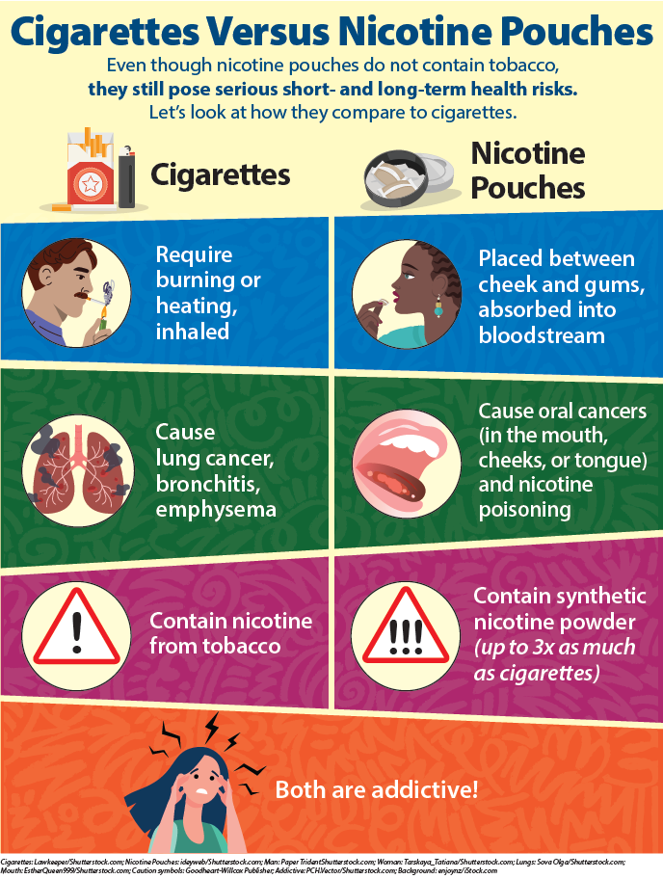
Name:
Date:
Period:

Student Worksheet

Responding Respectfully and Assertively
All or part of each statement that follows is inaccurate. Based on what you have just learned about oral nicotine pouches, determine the incorrect information about each statement. Then, write what you might say to the person making the statement. Remember to be respectful.
Statement | What about this statement is incorrect? | How would you respond to the person making the statement?
You overheard two students talking in the restroom. One said, “Oral nicotine pouches are safe. It’s just a pouch that you put in your mouth. My friend did it a bunch, and nothing bad happened.” | Answer: | Answer:
Your friend says, “Honestly, I don’t think oral nicotine patches are bad for your health because you don’t even inhale it like smoking or vaping.” | Answer: | Answer:
You overhear a classmate say, “Oral nicotine patches are so easy to hide. There is no way I’ll get caught or even get in trouble.” | Answer: | Answer:

Now, imagine that you are being pressured to try an oral nicotine pouch. Read the following scenarios and use refusal skills to assertively communicate “No.” Practice communicating “No” in several different ways. Once complete, role play one of the scenarios with a partner.
Pressure Lines | Refusal Lines
While getting ready for PE class, a student says to you, “Need a boost of energy? Here, take this oral nicotine pouch. It’ll really get you going.” | Your response:
While walking home from school, a friend says to you, “Oral nicotine pouches are so much safer than smoking or vaping. Aren’t you curious? The flavors taste great too. Just try it.” | Your response:
While studying, your older sibling says “You are seriously zoned out. Put this oral nicotine pouch in your mouth. It helps me focus and feel more alert.” | Your response:

Answer Key

Lesson Review
- True or false: Oral nicotine pouches contain parts of the tobacco plant like tobacco leaves. (LO 1)
Answer: False.
- List three possible symptoms of nicotine poisoning. (LO 2)
Answer: List two: vomiting, increased salivation, abdominal pain, sweating, high heart rate, low blood pressure, rapid and shallow breathing, headaches, dizziness, tremors, seizures, loss of muscle control, an inability to walk
- What two phrases are prohibited from being used in oral nicotine pouch marketing? (LO 3)
Answer: “safe” and “FDA approved”
- Explain the importance of standing firm once you have stated your refusal to someone. (LO 4)
Answer: Answers will vary, but should indicate the possibility of continued pressure and lack of respect for your choices.

