Name:
Class:
Date:

Activity 1.1A: How Big Is Agriculture?

Materials Needed
- Crayons or markers
- Posterboard or larger sheet of paper

Instructions
Agriculture has a broad scope, given the land, money, and employment it affects. Read the passage and then color the items as directed.

Global Land Use
The surface of Earth is about 197 million square miles. To understand the scope of agriculture, it is important to recognize the amount of land being used for agriculture and food production. Use the boxes below to guide your analysis of agricultural land use.

- It is estimated that 70% of Earth’s surface is covered by water. To represent this area, color 70 of the boxes blue.
- The 30 boxes remaining represent the land on Earth. Of this land, just over half is unsuitable for humans to live, graze animals, or grow crops. This includes areas in the Arctic, deserts, the tops of rocky mountains, or swamps. Color 13 boxes brown to represent this area on Earth’s surface.
- The remaining 12 boxes represent the areas on earth that are habitable, or suitable for human life. Of this land, about 42% is covered by towns, cities, and buildings. Color five boxes red to represent this portion of the land.
- The remaining seven boxes are available for grazing, pastures, and growing crops. About 55% of this land is available for grazing, but not suitable for growing crops. Color four boxes yellow to represent this land area.
- The last three boxes represent the arable crop land currently in use for agricultural production in the world. Color them green.
- What surprises you about the graphic you just completed? Did you expect the graphic to show only three green boxes?
Answer:
- Some experts estimate that cropland in the United States is being lost at the rate of up to 2000 acres a day. How would you share with the public the importance of preserving cropland?
Answer:

Employment
- The percentage of employment in agriculture is very different in different countries. Use the following graphics to create a pie chart you can color to show the approximate percentage of agricultural employment for the three countries listed.
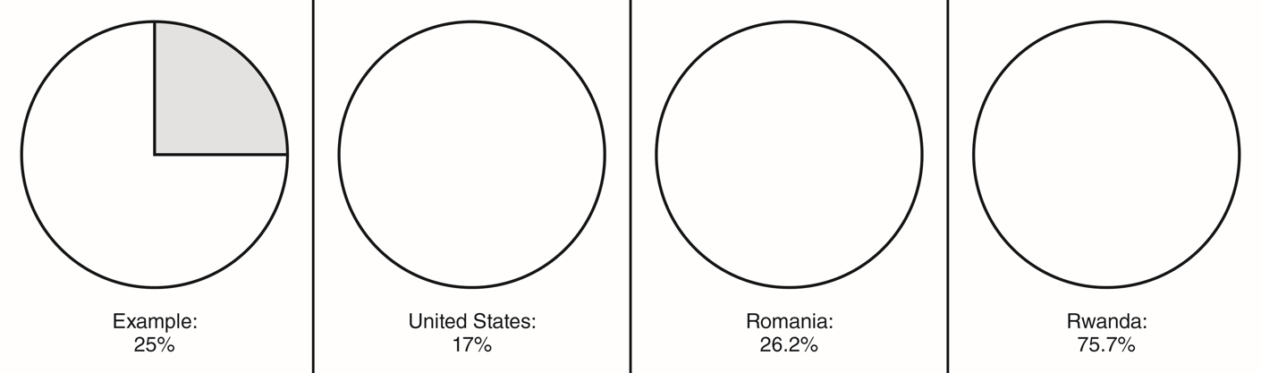
Goodheart-Willcox Publisher
- Explain some reasons why differences might exist in employment percentages in different countries. Hint: you may need to research some of the differences in countries in general.
Answer:

