Name:
Class:
Date:

Lesson 5.2: Biotechnology in Agriculture

Lesson Review
Carefully study the lesson and then answer the following questions.
- True or False? Biotechnology is a relatively new concept. (5.2.1)
Answer:
- List three examples of using living organisms to alter, improve, or create agricultural products. (5.2.1)
Answer:
- What is the difference between natural selection and artificial selection? (5.2.1)
Answer:
- What is genetic engineering? (5.2.2)
Answer:
- Organisms resulting from genetic engineering are called _____. (5.2.3)
- genetic misaligned organism
- genetically manipulated organism
- genetically modified organism
- general modification of the original
Answer:
- List three types of modifications currently used in agricultural GMOs. (5.2.3)
Answer:
- List three potential risks of using GMOs. (5.2.3)
Answer:
Match the type of reproductive biotechnology to the definition.
- Artificial insemination (AI)
- Cloning
- Embryo transfer
- Fertilized embryos are collected from a female to store them or place them in other females for growth and development. (5.2.4)
Answer:
- Placing semen in the female reproductive tract by artificial means. (5.2.4)
Answer:
- Creating a genetically identical copy of an organism. (5.2.4)
Answer:
Match the flushing equipment and the heifer’s anatomy to the correct terms. (5.2.4)
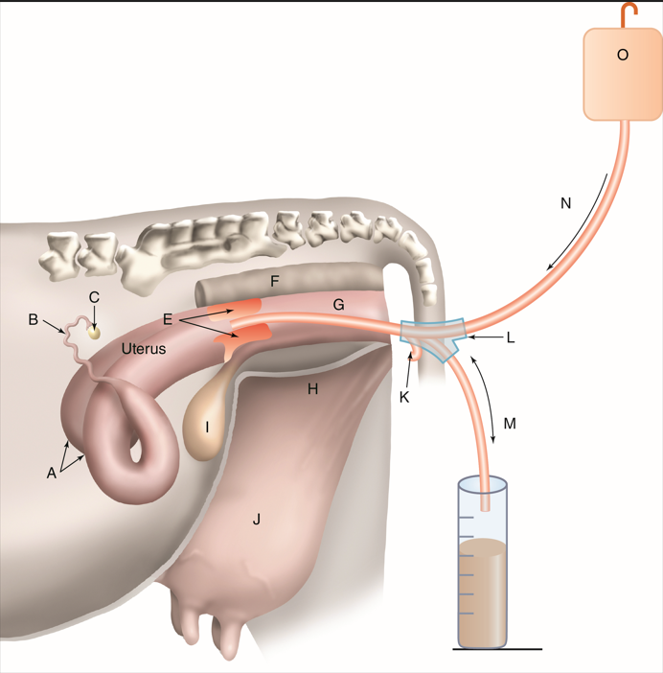
Peter Hermes Furian/Shutterstock.com
- Air
Answer:
- Bladder
Answer:
- Catheter
Answer:
- Cervix
Answer:
- Inward flow
Answer:
- Outward flow
Answer:
- Ovary
Answer:
- Oviduct
Answer:
- Rectum
Answer:
- Saline infusion bag
Answer:
- Udder
Answer:
- Uterine horns
Answer:
- Uterus
Answer:
- Vagina
Answer:
- Y-connector
Answer:
- An animal whose genetic makeup has been changed to carry genes from other species is called a _____ animal. (5.2.4)
- GMO
- recipient
- donor
- transgenic
Answer:
- True or False? The development and use of biotechnology is regulated by multiple governmental organizations. (5.2.5)
Answer:

Critical Thinking
- Much controversy surrounds the use of GMOs in the food supply. Some countries prohibit the import of GMOs or GMO products. Which side do you support? Do you believe GMOs should be widely used or avoided in the food supply? Consider factual evidence for your argument and write a letter to those who oppose your viewpoint, trying to persuade them to see your perspective. Be ready to share your letter with the class. (5.2.5)

