Name:
Class:
Date:

Lesson 7.1: Energy Systems

Lesson Review
Carefully study the lesson and then answer the following questions.
- Explain the difference between renewable and nonrenewable energy. (7.1.1)
Answer:
- Solar power is the _____ form of energy we use. (7.1.1)
- best
- least expensive
- newest
- cleanest
Answer:
- The special semiconductor diodes that convert visible light into DC electricity are called _____ cells. (7.1.1)
- solar
- photovoltaic
- battery
- diode
Answer:
- What is the most common type of wind turbine in the United States? (7.1.1)
- Nacelle axis turbine
- Horizontal-axis wind turbine (HAWT)
- Single-blade rotary turbine (SBRT)
- Air turbine
Answer:
- Wind speeds should be a minimum of _____ miles per hour for turbines to work efficiently. (7.1.1)
- 8
- 10
- 12
- 14
Answer:
Match the components of the wind turbine to the correct terms. (7.1.1)
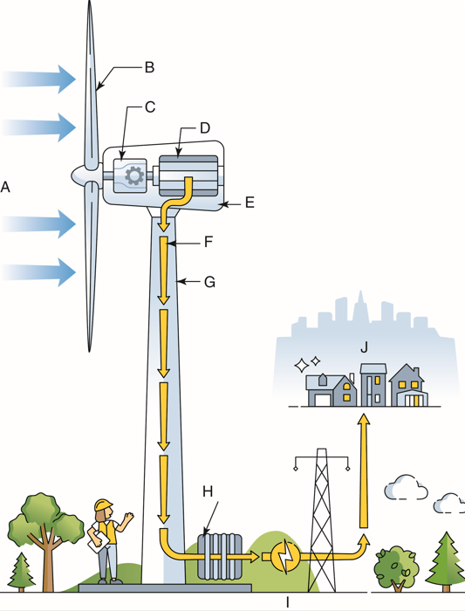
VectorMine/Shutterstock.com
- Consumer
Answer:
- Gear box
Answer:
- Generator
Answer:
- Nacelle
Answer:
- Power cables
Answer:
- Rotor blade
Answer:
- Switchyard
Answer:
- Tower
Answer:
- Transformer
Answer:
- Wind
Answer:
- True or False? Wind farms are generally placed only in locations far from the ocean. (7.1.1)
Answer:
- True or False? It is not economical to use single-turbine wind power in remote areas that are far from the power grid. (7.1.1)
Answer:
- True or False? Wind power is a power-supply method for reducing carbon and water pollution. (7.1.1)
Answer:
Match the offshore wind farm components to the correct terms. (7.1.1)
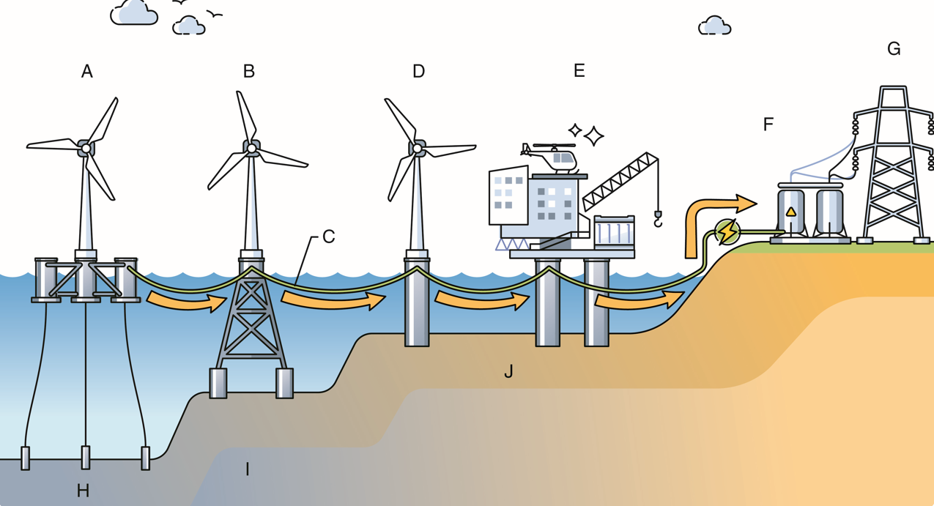
VectorMine/Shutterstock.com
- Floating
Answer:
- Jacket
Answer:
- Power cables
Answer:
- Monopile
Answer:
- Offshore substation
Answer:
- Onshore substation
Answer:
- Power grid
Answer:
- Deep water
Answer:
- Transitional water
Answer:
- Shallow water
Answer:
- About _____ of the total electricity generated in the United States comes from hydroelectric power. (7.1.1)
- 2%
- 6%
- 25%
- 50%
Answer:
- List three environmental impacts that might come from installing a hydroelectric dam. (7.1.1)
Answer:
Match the dam components to the correct terms. (7.1.1)
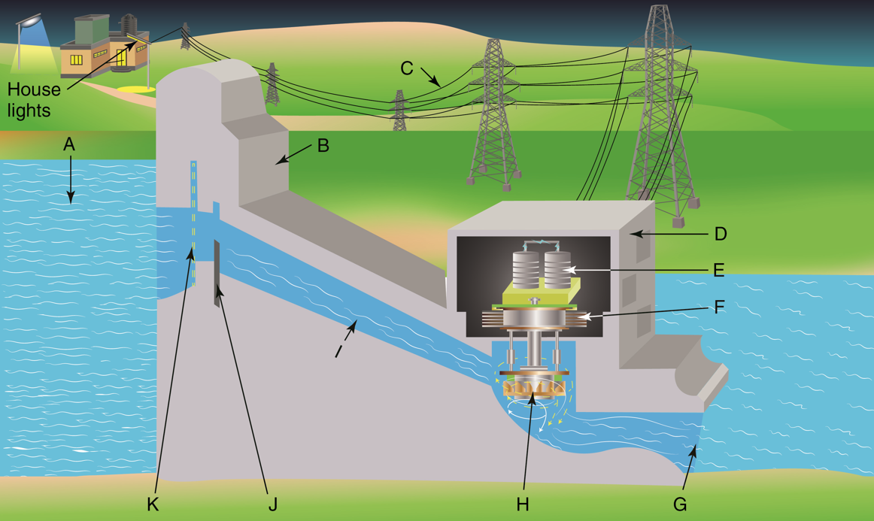
snapgalleria/Shutterstock.com
- Control gate
Answer:
- Dam
Answer:
- Generator
Answer:
- Intake
Answer:
- Outflow
Answer:
- Penstock
Answer:
- Power lines
Answer:
- Powerhouse
Answer:
- Reservoir
Answer:
- Transformer
Answer:
- Turbine
Answer:
Match each type of geothermal system to the definition.
- Dry steam system
- Flash steam system
- Binary cycle system
- Hot water passes through a heat exchanger, where it heats a second liquid. (7.1.1)
Answer:
- Hot water is depressurized into steam, which drives a turbine. (7.1.1)
Answer:
- Steam goes through a turbine and is then condensed into water. (7.1.1)
Answer:
- True or False? Geothermal heat pumps can only be used in areas with large amounts of underground geothermal activity. (7.1.1)
Answer:
- True or False? Biomass energy comes from burning materials that are quickly replenished by nature. (7.1.1)
Answer:
- True or False? Biomass power plants are often located hundreds of miles from the source of the biomass they use. (7.1.1)
Answer:
- True or False? Natural gas emitted from the source has a distinctively bad odor. (7.1.2)
Answer:
- True or False? More than half of all American homes use natural gas for heating and cooking. (7.1.2)
Answer:
- True or False? Humans have used crude oil for thousands of years. (7.1.2)
Answer:
- List the four steps in getting crude oil from the ground to refineries. (7.1.2)
Answer:
- There are _____ crude oil refineries in the United States. (7.1.2)
- over 100
- over 130
- over 180
- over 250
Answer:
- Almost _____ of the energy produced in the United States comes from nuclear energy. (7.1.2)
- 5%
- 10%
- 20%
- 40%
Answer:

Critical Thinking
- If you had the choice to select three energy sources the United States could use to produce electrical power, which three types of energy systems would you choose and why? (7.1.0)
Answer:

