Name:
Class:
Date:

Lesson 7.3: Agricultural Hand Tools

Lesson Review
Carefully study the lesson and then answer the following questions.
- What are the six general safety rules for working with tools? (7.3.1)
Answer:
Match the measuring tool to its definition.
- Tape measure
- Folding rule
- Square
- A good tool for measuring in specific situations; includes zigzag-type rules (7.3.2)
Answer:
- Flexible fabric, steel, or plastic that extends and retracts in a handheld case (7.3.2)
Answer:
- L- or T-shaped tool that allows lengths and angles to be measured (7.3.2)
Answer:
- True or False? You should hold a hammer as close to the head as possible. (7.3.2)
Answer:
- True or False? You should hold the nail near the top. (7.3.2)
Answer:
- True or False? You should hold a hammer as tightly as possible to prevent letting go. (7.3.2)
Answer:
- True or False? There are only one or two types of hammers. (7.3.2)
Answer:
- True or False? There are tools specifically designed to be used as prying tools. (7.3.2)
Answer:
- The _____ determines the type of screwdriver needed. (7.3.2)
- type of wood or metal being attached
- strength of the person using the screwdriver
- experience of the user using a screwdriver
- type of fastener requiring tightening or removal
Answer:
- Wrenches are available in which two size systems? (7.3.2)
Answer:
Match the type of wrench to the definition.
- Adjustable wrench
- Allen wrench
- Box-end wrench
- Combination wrench
- Open-end wrench
- Pipe wrench
- Socket wrench
- Strap wrench
- Nonadjustable wrench with openings at each end (7.3.2)
Answer:
- Open-ended with one stationary jaw and one adjustable jaw (i.e., a crescent wrench) (7.3.2)
Answer:
- Adjustable self-tightening wrenches with hardened toothed jaws and a strong grip (7.3.2)
Answer:
- L- or T-shaped wrenches with a hexagonal shaft (7.3.2)
Answer:
- Specialized wrench with a ratcheting mechanism to turn the nut or bolt (7.3.2)
Answer:
- Self-tightening wrenches that can be pulled tight around cylindrical objects (7.3.2)
Answer:
- Wrenches with open jaws on one end and closed jaws on the other end (7.3.2)
Answer:
- Nonadjustable wrenches that are closed at both ends (7.3.2)
Answer:
Identify the pliers illustrated.
- 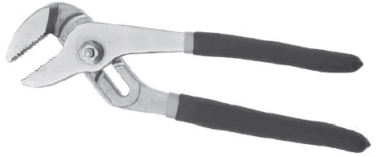
@erics/Shutterstock.com
Answer:
- 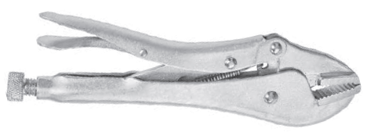
Zygotehaasnobrain/Shutterstock.com
Answer:
- 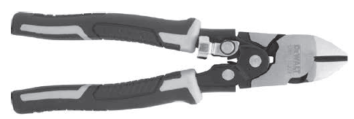
Provided courtesy of DeWALT Industrial Tool Co.
Answer:
- 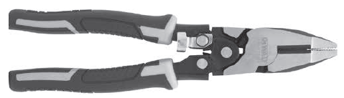
Provided courtesy of DeWALT Industrial Tool Co.
Answer:
- 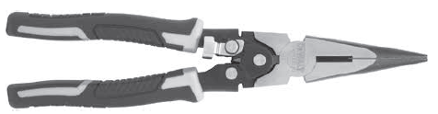
Provided courtesy of DeWALT Industrial Tool Co.
Answer:
- 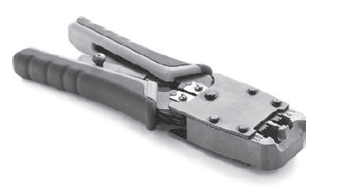
samsonovs/Shutterstock.com
Answer:
- 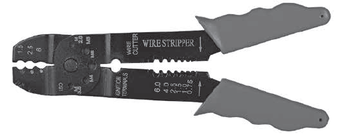
ConstantinosZ/Shutterstock.com
Answer:
- 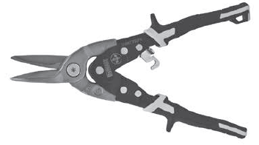
Provided courtesy of DeWALT Industrial Tool Co.

Answer:
- Tools designed to be struck by a hammer or wooden mallet to insert or remove other items are called _____. (7.3.2)
- chisels
- punches
- pliers
- screwdrivers
Answer:
- Which of the following is a specialized tool for cutting metal, made of hardened steel? (7.3.2)
- Nail set
- Wood chisel
- Pin punch
- Cold chisel
Answer:
- List and describe four common fasteners. (7.3.3)
Answer:
- What are the two basic types of hand saws used in carpentry? (7.3.4)
Answer:
- Planes are used for trimming, squaring, and _____ the edges of lumber. (7.3.4)
- smoothing
- roughing up
- shortening
- lengthening
Answer:

Critical Thinking
- As you read through all of the safety tips in this chapter, identify three common safety tips you think should apply regardless of the hand tool you are using. (7.3.1)
Answer:

