Name:
Class:
Date:

Lesson 7.4: Agricultural Power Tools and Equipment

Lesson Review
Carefully study the lesson and then answer the following questions.
- What are the six general safety rules for working with power tools? (7.4.0)
Answer:
- True or False? Most power tools have automatic off sensors, so you do not need to unplug them to repair them. (7.4.0)
Answer:
- True or False? Drill presses are similar to handheld power drills. (7.4.1)
Answer:
- True or False? Band saws are used widely in the meat processing industry. (7.4.2)
Answer:
- All of the following are band saw safety precautions, except _____. (7.4.2)
- Never place your fingers, hands, or arms in line with the blade
- Never stand to the left of the saw while it is in operation
- Always wear proper eye protection when using band saws
- Make sure the saw blade has been installed properly before using the saw
Answer:
- True or False? Portable power tools have an entirely different set of safety rules from stationary tools. (7.4.3)
Answer:
- True or False? The blade on a circular saw spins counterclockwise. (7.4.3)
Answer:
- True or False? Most portable power tools are safe to be used in wet conditions. (7.4.3)
Answer:
- Explain how jigsaws and reciprocating saws function. (7.4.3)
Answer:
Match the circular saw components to the correct terms. (7.4.3)
- Blade
Answer:
- Blade locking bolt
Answer:
- Exhaust
Answer:
- Guard
Answer:
- Handhold
Answer:
- Handle
Answer:
- Power cord
Answer:
- Shoe or base
Answer:
- Tilt adjustment
Answer:
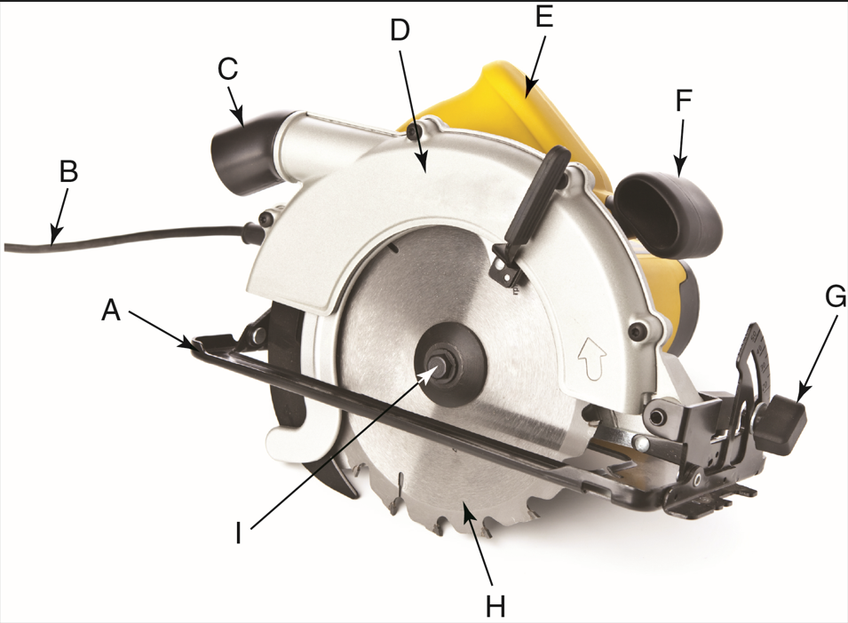
tale/Shutterstock.com

Match the table saw components to the correct terms. (7.4.4)
- Adjustable leveling feet
Answer:
- Angle and height adjustment
Answer:
- Blade
Answer:
- Blade guard
Answer:
- Fence
Answer:
- Power cord
Answer:
- Table adjustment
Answer:
- Table
Answer:
- Table slot
Answer:
- Telescoping rails
Answer:
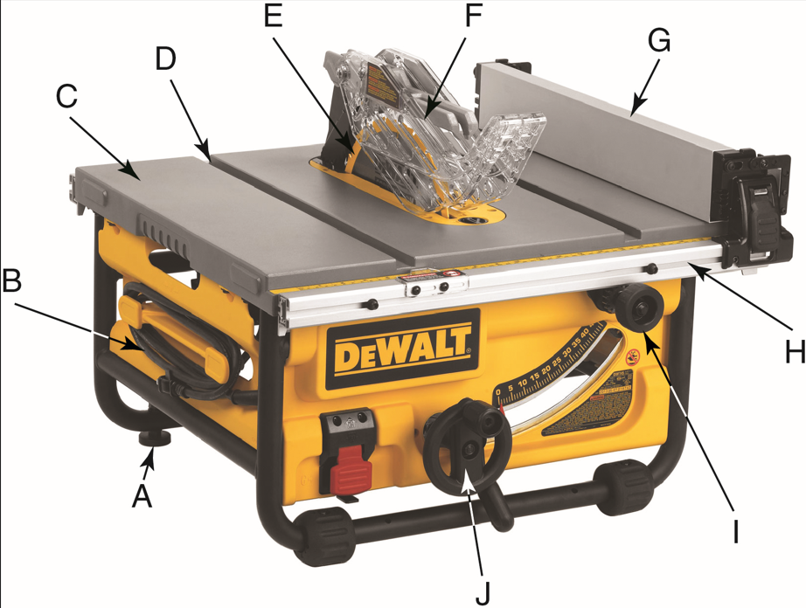
Provided courtesy of DeWALT Industrial Tool Co.
Match the miter saw components to the correct terms. (7.4.4)
- Blade
Answer:
- Blade guard
Answer:
- Dust bag
Answer:
- Fence
Answer:
- Fixed blade guard
Answer:
- Handle
Answer:
- Miter lock handle
Answer:
- Miter scale
Answer:
- Motor
Answer:
- Table
Answer:
- Trigger switch
Answer:
- Turn base
Answer:
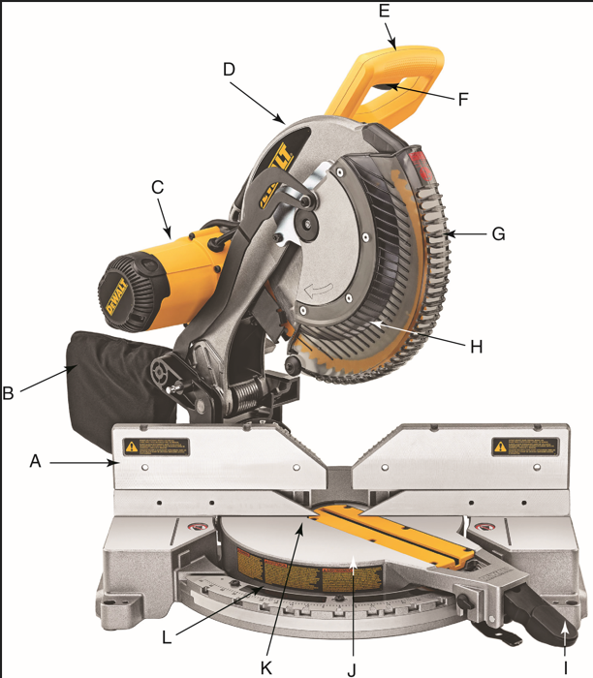
Provided courtesy of DeWALT Industrial Tool Co.
- True or False? Portable power drills are one of the most versatile power tools available. (7.4.3)
Answer:
- Which power tool uses blades to shape the surfaces and edges of wood stock? (7.4.0)
- Reciprocating Saw
- Jigsaw
- Router
- Grinder
Answer:
- True or False? Sanders and grinders have opposite uses: one takes material off, one puts material on. (7.4.3)
Answer:
Match the sander to its description.
- Belt-and-disk sander
- Belt sander
- Orbital sander
- Oscillating spindle sander
- Random orbital sander
- Best used for the initial smoothing of large, flat surfaces (7.4.3)
Answer:
- Easy to control and mainly used for finish sanding and removing old finish from smaller workpieces (7.4.3)
Answer:
- A lightweight sander that uses two simultaneous motions (7.4.3)
Answer:
- A combination stationary sander that is useful for sanding square or curved ends on narrow boards (7.4.3)
Answer:
- A stationary power sander that uses a spindle that rotates and moves up and down at the same time (7.4.3)
Answer:
- What are the two basic types of adjustments on a table saw? (7.4.4)
Answer:
- Explain the difference between a table saw and a radial arm saw. (7.4.4)
Answer:
- Pneumatic tools use _____ as power to operate. (7.4.5)
- propane
- specialized fluids
- petroleum
- compressed gas
Answer:
- List the two broad categories of petroleum-powered tools. (7.4.6)
Answer:

Critical Thinking
- As you read through all of the safety tips in this chapter, identify three common safety tips you think should apply regardless of the power tool you are using. (7.4.0)
Answer:

