Name:
Class:
Date:

Lesson 7.5: Agricultural Design and Fabrication

Lesson Review
Carefully study the lesson and then answer the following questions.
- The most important phase of any project is the _____ phase. (7.5.0)
- project
- fabrication
- sketch
- design
Answer:
- List the four steps in the design phase. (7.5.1)
Answer:
- Explain the difference between a sketch and a formal drawing. (7.5.2)
Answer:
Match the type of drawing to the definition.
- Assembly drawing
- Detail drawing
- Orthographic drawing
- Orthographic projection
- Pictorial drawing
- Sectional drawing
- Shows how an object would look if a cut were made through the object (7.5.2)
Answer:
- Shows a likeness of the object as viewed by the human eye (7.5.2)
Answer:
- Includes views of the product with dimensions and other important information (7.5.2)
Answer:
- An object drawn as a two-dimensional drawing (7.5.2)
Answer:
- Shows how the components of a project fit together (7.5.2)
Answer:
- Shows all surfaces on an object projected onto flat planes (7.5.2)
Answer:
- The relationship between the size of the object in the drawing and the size of the actual constructed object is called the _____. (7.5.2)
- scale
- dimension
- orthographic comparison
- proportion
Answer:
Match the symbol to its meaning.
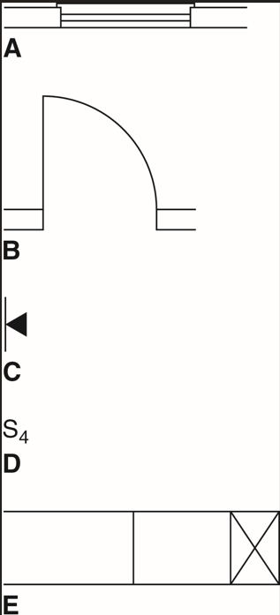
Goodheart-Willcox Publisher
- Door (7.5.2)
Answer:
- Four-way switch (7.5.2)
Answer:
- Supply duct turned up (7.5.2)
Answer:
- Telephone (7.5.2)
Answer:
- Window (7.5.2)
Answer:
- When should you take measurements during a structural project? (7.5.3)
- At the beginning of the project
- After some of the construction has been completed
- Once the project is completed
- Before, during, and after the project
Answer:
- List three basic measuring tools. (7.5.3)
Answer:
- True or False? The longer a level is, the less accurate it is over long distances. (7.5.0)
Answer:
- True or False? A chalk reel is commonly used to mark straight lines over a long distance. (7.5.0)
Answer:
Match each construction drawing to the correct definition.
- Assembly drawings
- Elevation plans
- Floor plans
- Site plans
- Common construction drawings showing a layout of rooms, doors, and other features (7.5.4)
Answer:
- Drawings of the land where the project will be constructed (7.5.4)
Answer:
- Show how the structure or piece of equipment is to be constructed (7.5.4)
Answer:
- Portray the building from one side (7.5.4)
Answer:

Critical Thinking
- Why is it important to have a new building inspected? (7.5.6)
Answer:

