Name:
Class:
Date:

Lesson 7.7: Principles of Electricity

Lesson Review
Carefully study the lesson and then answer the following questions.
- How many kilowatt-hours per year does the average US home use? (7.7.0)
- 5,000 kilowatt-hours
- 11,000 kilowatt-hours
- 20,000 kilowatt-hours
- 86,000 kilowatt-hours
Answer:
- Very small particles called _____ make up all matter. (7.7.1)
Answer:
Match the parts of an atom to the description.
- Electrons
- Neutrons
- Nucleus
- Protons
- Particles in the center of an atom that carry a positive charge (7.7.1)
Answer:
- Particles that orbit the center of an atom that carry a negative charge (7.7.1)
Answer:
- The central portion of an atom (7.7.1)
Answer:
- Particles in the center of an atom that carry no charge (7.7.1)
Answer:
- True or False? An atom with a negative charge is called a cation. (7.7.1)
Answer:
- Which of the following is another term for electrical potential? (7.7.1)
- Resistance
- Circuit
- Anion
- Voltage
Answer:
- Define electrical current. (7.7.2)
Answer:
- Describe the difference between conductors and insulators. (7.7.2)
Answer:
- True or False? Direct current is an electrical current flowing in only one direction. (7.7.3)
Answer:
- True or False? Alternating current is rarely generated by an electric generator. (7.7.3)
Answer:
- List three different elements of electricity that can be measured. (7.7.4)
Answer:
- Chemicals inside the battery produce an electrical _____ when the positive and negative ends are attached to conductors. (7.7.5)
- charge
- circuit
- ampere
- watt
Answer:
- What is the complex system of lines and substations that connects power plants to homes and businesses called? (7.7.6)
- Electromagnetic induction
- Ampere
- Grid
- Transformer
Answer:
- What device increases or decreases the voltage in a power line? (7.7.6)
- Electromagnetic induction
- Ampere
- Grid
- Transformer
Answer:
- True or False? Wrap the wire counterclockwise around the screw when fastening conductors to a switch or receptacle. (7.7.6)
Answer:
Match the components to the correct term.
- Cable
Answer:
- Light switch
Answer:
- Power source
Answer:
- Wire nut
Answer:
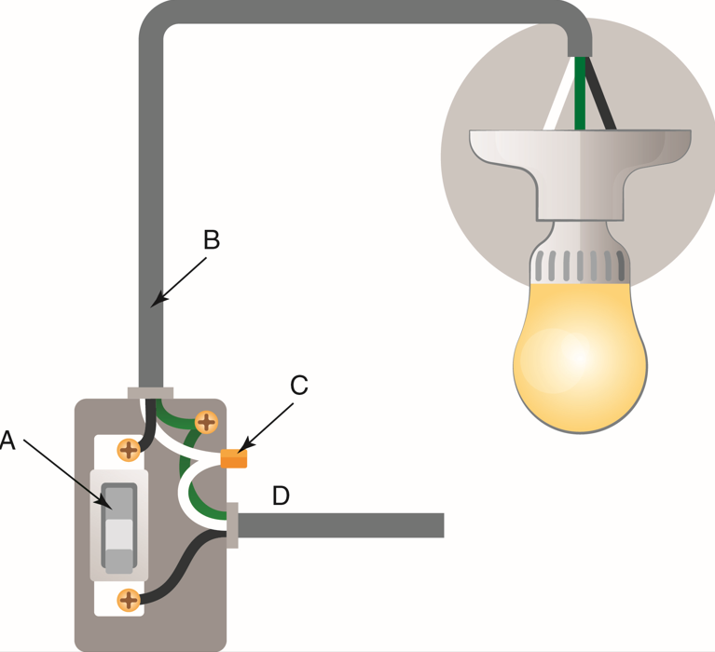
VectorMine/Shutterstock.com
- List four safety precautions to take when working with electricity. (7.7.7)
Answer:
- List seven basic hand tools used by electricians. (7.7.9)
Answer:
Match each term with the corresponding description.
- Electrical potential
- Volumetric efficiency
- Resistance
- Electrical power output
- Measured in volts (7.7.10)
Answer:
- Measured in watts (7.7.10)
Answer:
- Measured in ohms (7.7.10)
Answer:
- Measured in amperes (7.7.10)
Answer:

Critical Thinking
- Why is it important to use a licensed electrician? What could go wrong if an unlicensed person performed the electrical repairs or installation? (7.7.0)
Answer:

