Name:
Class:
Date:

Lesson 9.3: Animal Feeds and Feeding

Lesson Review
Carefully study the lesson and then answer the following questions.
- What is nutrition? (9.3.1)
Answer:
- The single most important nutrient for any animal is _____. (9.3.2)
- water
- carbohydrates
- fats
- protein
Answer:
- Chicken consists of _____ water. (9.3.2)
- 33%
- 50%
- 66%
- 75%
Answer:
- Grains in animal feeds are made of _____ carbohydrates. (9.3.2)
- 40%–50%
- 50%–60%
- 60%–70%
- 70%–80%
Answer:
- When compared to carbohydrates, _____ times more energy is contained in lipids. (9.3.2)
- 2
- 2.25
- 2.5
- 2.75
Answer:
- Proteins are made of smaller molecules called _____. (9.3.2)
- muscle
- vitamins
- amino acids
- tissue
Answer:
- Plants that have a symbiotic relationship with bacteria, allowing them to process nitrogen into protein, are called _____. (9.3.2)
- forage
- legumes
- protein-rich
- litter
Answer:
- What is the difference between vitamins and minerals? (9.3.2)
Answer:
Match the nutrient to its major function in the animal body.
- Water
- Carbohydrates
- Fats
- Protein
- Vitamins
- Minerals
- Provides readily available nutrients (9.3.2)
Answer:
- Responsible for building and repairing cells (9.3.2)
Answer:
- Form structures, produce enzymes, and carry oxygen (9.3.2)
Answer:
- The most limiting nutrient, controls many life processes (9.3.2)
Answer:
- Involved in the regulation of metabolism (9.3.2)
Answer:
- Provide long-term energy storage (9.3.2)
Answer:
- List four factors that can help determine the amount of nutrients an animal needs. (9.3.3)
Answer:
Match the terms to their definition.
- Balanced ration
- Concentrate
- Fiber
- Palatability
- Ration
- Roughage
- Total digestible nutrients (TDNs)
- The amount of feed an animal consumes in a day (9.3.3)
Answer:
- Very complex carbohydrates (9.3.3)
Answer:
- Feed low in TDN and high in fiber (9.3.3)
Answer:
- How desirable an animal finds a foodstuff (9.3.3)
Answer:
- Feed high in TDN and low in fiber (9.3.3)
Answer:
- The sum of the digestible fiber, protein, lipids, and carbohydrates in a feed (9.3.3)
Answer:
- All of the necessary nutrients for an animal’s intended growth and development (9.3.3)
Answer:
- True or False? Methods of processing feed can play a role in the amount of nutrients the animal obtains. (9.3.4)
Answer:
- True or False? Feeds that have similar nutritional content have almost identical costs. (9.3.4)
Answer:
- True or False? Feeding livestock can also play an important role in recycling. (9.3.4)
Answer:
- Define digestion. (9.3.5)
Answer:
- Describe what happens in each of the steps of digestion. (9.3.5)
Answer:
Match the parts of the ruminant digestive system to their names. (9.3.5)
- Abomasum
Answer:
- Cecum
Answer:
- Colon
Answer:
- Esophagus
Answer:
- Omasum
Answer:
- Rectum
Answer:
- Reticulum
Answer:
- Small intestine
Answer:
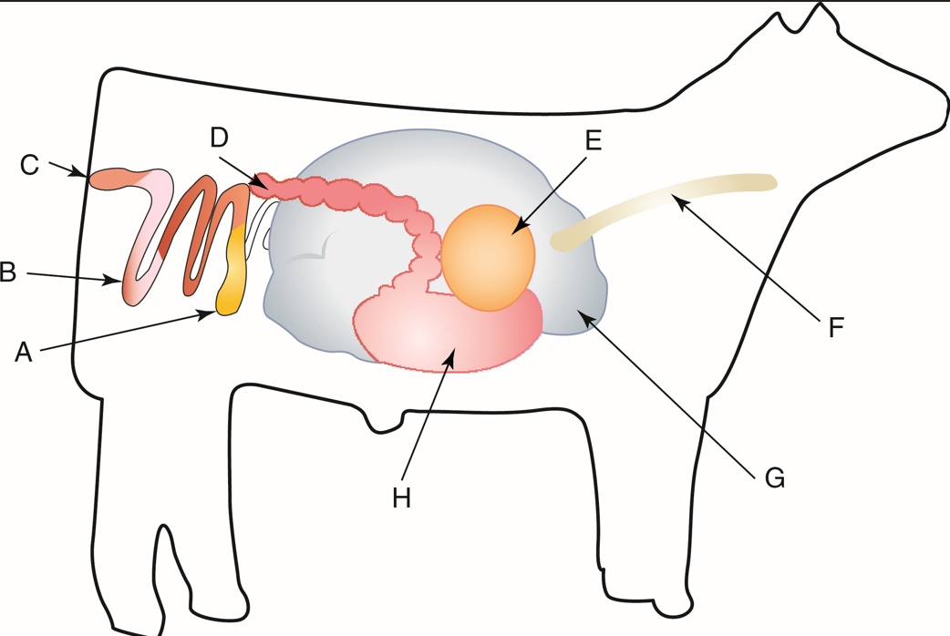
TAMU Livestock Judging
Match the parts of the ruminant digestive system to their function.
- Reticulum
- Rumen
- Omasum
- Abomasum
- Where digestive chemicals are added for the chemical breakdown of food (9.3.5)
Answer:
- Contains microbes to help break down fiber (9.3.5)
Answer:
- Sorts feed and removes any foreign objects (9.3.5)
Answer:
- Takes broken-down feed and removes excess water (9.3.5)
Answer:
- Which of the following animals has a ruminant digestive system? (9.3.5)
- Dog
- Goat
- Horse
- Chicken
Answer:
- Which of the following animals has a monogastric digestive system? (9.3.5)
- Dog
- Goat
- Horse
- Chicken
Answer:
- Which of the following animals has a modified monogastric digestive system? (9.3.5)
- Dog
- Goat
- Horse
- Chicken
Answer:
- Which of the following animals has an avian digestive system? (9.3.5)
- Dog
- Goat
- Horse
- Chicken
Answer:
Match the common digestive disorder to its description.
- Acidosis
- Bloat
- Colic
- Scours
- Extreme diarrhea in young animals (9.3.5)
Answer:
- Number one cause of death in horses (9.3.5)
Answer:
- Excessive gases built up in rumen (9.3.5)
Answer:
- A high pH level in a rumen for an extended period of time (9.3.5)
Answer:
Match the swine digestive system components to the correct terms. (9.3.5)
- Cecum
Answer:
- Duodenum
Answer:
- Esophagus
Answer:
- Gall bladder
Answer:
- Large intestine
Answer:
- Liver
Answer:
- Pancreas
Answer:
- Rectum
Answer:
- Salivary gland
Answer:
- Small intestine
Answer:
- Stomach
Answer:
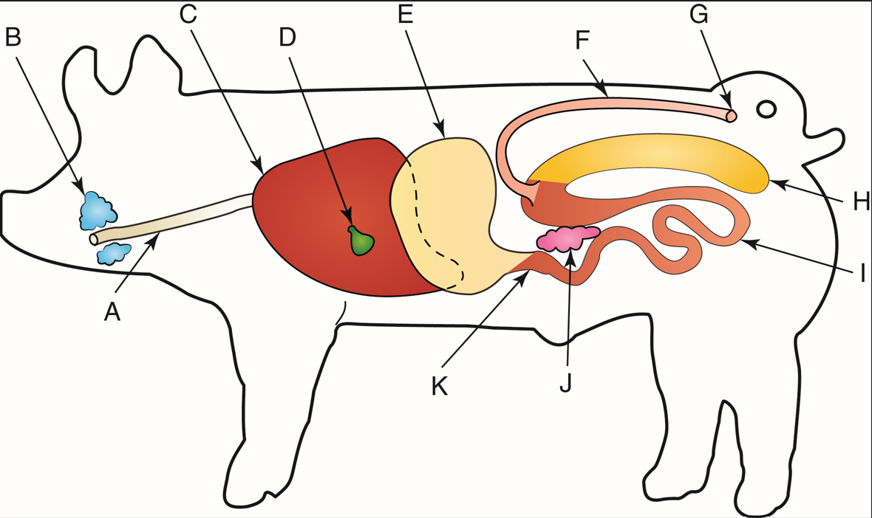
TAMU Livestock Judging
Match the equine digestive system components to the correct terms. (9.3.5)
- Anus
Answer:
- Cecum
Answer:
- Esophagus
Answer:
- Large colon
Answer:
- Liver
Answer:
- Rectum
Answer:
- Small colon
Answer:
- Small intestine
Answer:
- Stomach
Answer:
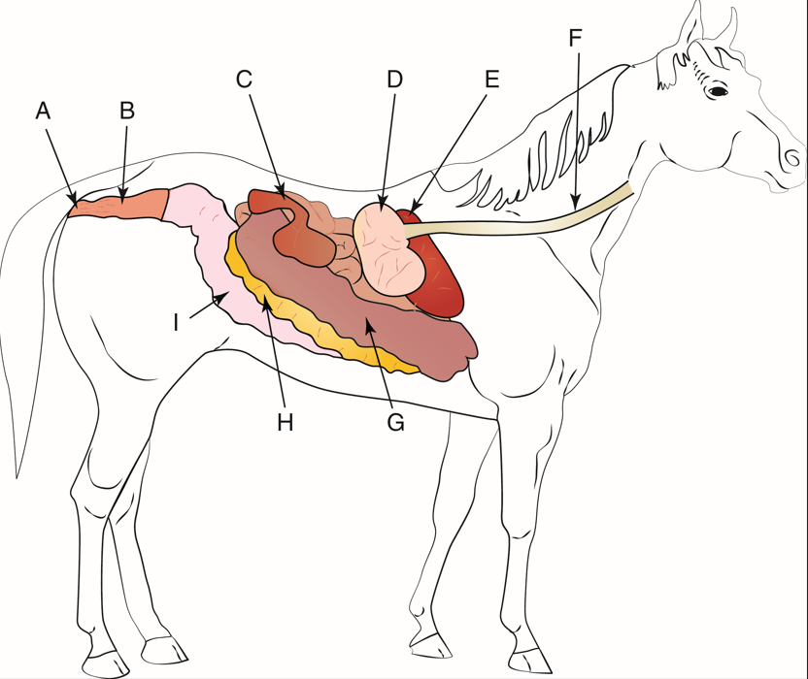
Goodheart-Willcox Publisher
Match the avian digestive system components to the correct terms. (9.3.5)
- Ceca
Answer:
- Cloaca
Answer:
- Colon
Answer:
- Crop
Answer:
- Duodenum
Answer:
- Esophagus
Answer:
- Gall bladder
Answer:
- Gizzard
Answer:
- Jejunum
Answer:
- Large intestine
Answer:
- Liver
Answer:
- Proventriculus
Answer:
- Small intestine
Answer:
- Spleen
Answer:
- Vent
Answer:
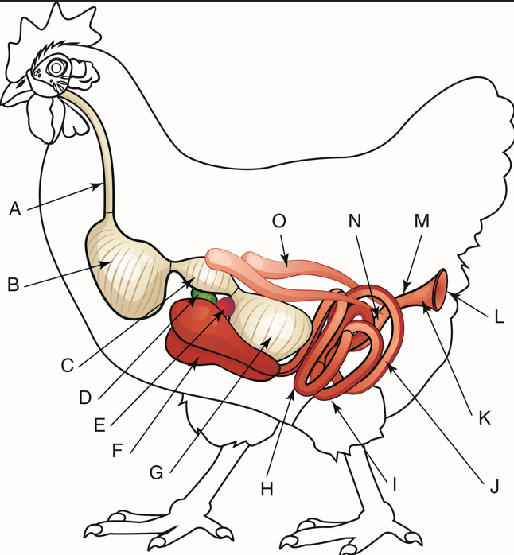
VectorMine/Shutterstock.com

Critical Thinking
- Now that you understand how the different types of digestive systems work, explain why you could feed a cow lower-quality feed than you would feed a horse and still see the animal grow and develop. (9.3.5)
Answer:

