Name:
Class:
Date:

Lesson 10.1: The Beef Industry

Lesson Review
Carefully study the lesson and then answer the following questions.
- There are approximately _____ beef cattle in the United States. (10.1.1)
- 76.2 million
- 79.6 million
- 86.7 million
- 94.8 million
Answer:
- List the top five states in beef cattle production. (10.1.1)
Answer:
Match each of the bovine terms to its definition.
- Calf
- Bull calf
- Steer
- Heifer
- Cow
- Calving
- Castrated male (10.1.2)
Answer:
- Mature female (10.1.2)
Answer:
- Young of either gender (10.1.2)
Answer:
- Young female (10.1.2)
Answer:
- Young male (10.1.2)
Answer:
- Giving birth (10.1.2)
Answer:
- The gestation period of a cow is _____. (10.1.2)
- 250–268 days
- 265–283 days
- 279–290 days
- 292–314 days
Answer:
- List the age at which each of the following occurs in beef cattle. (10.1.2)
- Weaning:
Answer:
- Breeding age (bulls):
Answer:
- Breeding age (heifers):
Answer:
Match the bovine operation to its definition.
- Cow-calf operations
- Backgrounding operations
- Feedlots
- Seedstock operations
- Produce bulls, heifers, and cows that are used as breeding animals (10.1.3)
Answer:
- Produce calves and sell at weaning age (10.1.3)
Answer:
- Use grazing pastures for cattle to provide moderate weight gain from weaning through finishing (10.1.3)
Answer:
- Cattle spend 4–6 months in these operations and are fed diets to increase their fat deposition (10.1.3)
Answer:
Label the external anatomy of beef cattle. (10.1.4)
- Cannon
Answer:
- Chest floor
Answer:
- Crest
Answer:
- Dewlap
Answer:
- Face
Answer:
- Flank
Answer:
- Forerib
Answer:
- Heart
Answer:
- Hip
Answer:
- Hock
Answer:
- Hoof
Answer:
- Hooks
Answer:
- Knee
Answer:
- Loin
Answer:
- Muzzle
Answer:
- Neck
Answer:
- Pastern
Answer:
- Pins
Answer:
- Point of shoulder
Answer:
- Poll
Answer:
- Quarter
Answer:
- Ribs
Answer:
- Sheath
Answer:
- Shoulder
Answer:
- Stifle muscle
Answer:
- Switch
Answer:
- Tailhead
Answer:
- Top of shoulder
Answer:
- Underline
Answer:
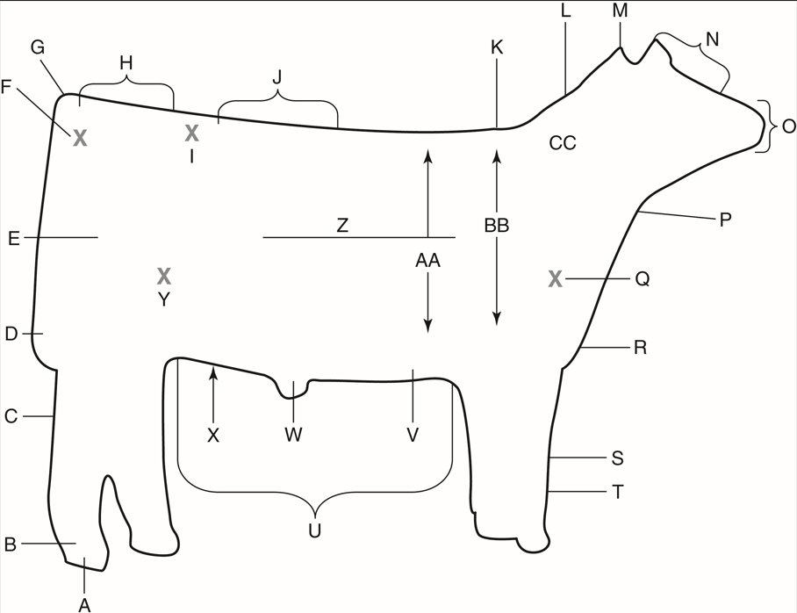
TAMU Livestock Judging
- True or False? Herd animals will imitate the actions of the animals closest to them. (10.1.5)
Answer:
- True or False? Herd animals will individually make a conscious decision about which direction to move in. (10.1.5)
Answer:
- True or False? New animals can always be introduced into most herds without issues. (10.1.5)
Answer:
- List three important points to keep in mind related to maintaining beef cattle herd health. (10.1.5)
Answer:
- True or False? Cattle should be selected based primarily on the breed the producer likes best. (10.1.5)
Answer:
- True or False? Human contact with beef cattle should be kept to a minimum to allow them to bond with each other. (10.1.5)
Answer:
- True or False? Young calves should be handled at an early age if they are going to be exhibited. (10.1.5)
Answer:
Match the primal cut of beef to its definition. (10.1.6)
- Brisket
- Chuck
- Flank
- Loin
- Offal
- Plate
- Rib
- Round
- Fairly tough, boneless primal cut of meat from the front belly
Answer:
- Edible organs of cattle
Answer:
- Primal cut from the section between the ribs and the round, and above the flank
Answer:
- Cut extending from the shoulder to the neck
Answer:
- Tough, fatty primal cut from the belly, just below the rib
Answer:
- Tender primal cut from the center section of the rib
Answer:
- Meat from the abdominal muscles
Answer:
- Meat from the hindquarters
Answer:
- List and describe the two subspecies of beef cattle. (10.1.7)
Answer:

Critical Thinking
- If you were going to be a beef cattle producer, which type of production would you most like to be involved (cow-calf, backgrounding, purebred, etc.)? Explain your answer. (10.1.3)
Answer:

