Name:
Class:
Date:

Lesson 10.2: The Dairy Industry

Lesson Review
Carefully study the lesson and then answer the following questions.
- More than _____ of the dairy cows in the United States are in California. (10.2.0)
- 11%
- 18%
- 25%
- 52%
Answer:
- List the top five states in dairy cattle production. (10.2.0)
Answer:
- The average dairy cow produces about _____ of milk each day. (10.2.1)
- 4.0 gallons
- 5.2 gallons
- 7.5 gallons
- 9.5 gallons
Answer:
- How much of the beef produced in the United States comes from dairy cattle? (10.2.1)
- 14%
- 18%
- 22%
- 26%
Match the dairy product to its definition.
- Butter
- Buttermilk
- Cheese
- Condensed milk
- Cream
- Evaporated milk
- Frozen yogurt
- Ice cream
- Sour cream
- Yogurt
- Product made by removing about 60% of the water from milk (10.2.1)
Answer:
- Churned product of milk or cream (10.2.1)
Answer:
- Cream that has been fermented by bacterial culture (10.2.1)
Answer:
- Milk and milk solids fermented by two added bacterial cultures (10.2.1)
Answer:
- Frozen dairy dessert containing active or inactive bacterial cultures (10.2.1)
Answer:
- Heavily sweetened milk product made by removing about 60% of the water content in milk (10.2.1)
Answer:
- Fatty liquid rising to the top of milk (10.2.1)
Answer:
- Sweet, frozen food made from no less than 10% butterfat (10.2.1)
Answer:
- Slightly sour liquid left over following the process of churning butter (10.2.1) B.
Answer:
- Solid food made from milk curd (10.2.1)
Answer:
- True or False? Dairy calves spend the first three months with the cow. (10.2.2)
Answer:
- True or False? Dairy heifers are typically bred at about 15 months of age. (10.2.2)
Answer:
- True or False? Only bull calves with superior genetics are kept for bulls in the dairy industry. (10.2.2)
Answer:
- True or False? Most dairy farms keep a bull and use natural breeding methods. (10.2.2)
Answer:
- True or False? A dairy cow will typically only stay in the production cycle for 2 or 3 years. (10.2.2)
Answer:
- Inflammation of the mammary glands, usually caused by bacteria, is called _____. (10.2.2)
- mastitis
- homogenization
- culling
- mammary
Answer:
- Lameness is a particular concern in dairy cows because _____. (10.2.2)
- they are large and have excess weight
- lactation causes stress on bones and tendons
- most of them are very old
- they walk mainly on concrete to enter the milking parlor
Answer:
- True or False? Most dairy cows are milked three times a day. (10.2.2)
Answer:
- List the seven steps in the milking process. (10.2.2)
Answer:
- Milk must be cooled to a temperature below 45°F within _____. (10.2.2)
- 30 minutes
- 1 hour
- 2 hours
- 4 hours
Answer:
- List the four requirements that milk must meet to follow industry standards. (10.2.2)
Answer:
- Heart girth refers to the size of a cow’s _____. (10.2.3)
- hooves
- chest floor
- heart
- lungs
Answer:
- Which of the following is not a practice used to maintain herd health? (10.2.4)
- Observe new animals for possible signs of diseases and parasites.
- Monitor cows during calving.
- Administer vaccines when after a cow in the herd becomes sick.
- Maintain a good working relationship with a large-animal veterinarian.
Answer:
- How much roughage does a cow need to eat per a day? (10.2.4)
- 30–35 lb
- 40–45 lb
- 50–55 lb
- 60–65 lb
Answer:
- True or False? Cows slipping and falling in the milking parlor should be a concern when handling dairy cows. (10.2.5)
Answer:
- True or False? Dairy bulls are typically very mean and aggressive. (10.2.5)
Match the dairy cow’s external anatomy to the correct term. (10.2.3)
- Milk wells
Answer:
- Mammary veins
Answer:
- Fore udder attachment
Answer:
- Fore udder
Answer:
- Teats
Answer:
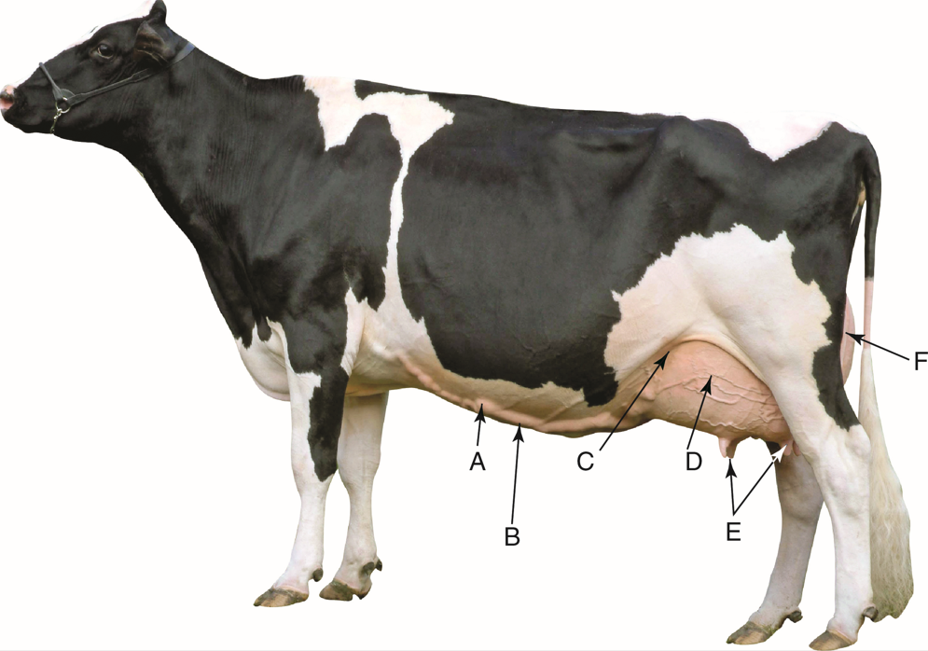
Courtesy of Hoard’s Dairyman

Critical Thinking
- What are the major differences between beef cattle structure and dairy cattle structure? (10.2.3)
Answer:

