Name:
Class:
Date:

Lesson 10.3: The Equine Industry

Lesson Review
Carefully study the lesson and then answer the following questions.
- Approximately how many horses are there in the United States? (10.3.1)
- 4.5 million
- 7.2 million
- 12.1 million
- 18.5 million
Answer:
- List the top five states by number of horses. (10.3.1)
Answer:
Match the equine term to its definition.
- Colt
- Filly
- Foal
- Gelding
- Jack
- Jenny or jennet
- Mare
- Stallion
- Female ass or donkey (10.3.1)
Answer:
- Castrated male (10.3.1)
Answer:
- Mature female horse (10.3.1)
Answer:
- Young of either gender (10.3.1)
Answer:
- Young female horse (10.3.1)
Answer:
- Young male horse (10.3.1)
Answer:
- Male ass or donkey (10.3.1)
Answer:
- A mature male horse that is not castrated (10.3.1)
Answer:
- How long is the gestation of a horse? (10.3.2)
- 250–265 days
- 265–300 days
- 300–335 days
- 335–370 days
Answer:
- True or False? Larger horse breeds have a longer gestation than smaller horse or pony breeds. (10.3.2)
Answer:
- True or False? A foal will nurse for 6–9 months before being weaned. (10.3.2)
Answer:
- True or False? Depending on the specific horse show, horses may be judged based on both their conformation and while being ridden. (10.3.2)
Answer:
- List three events for both English and western riding. (10.3.3)
- English:
Answer:
- Western:
Answer:
- Horses that have been selected for ranch-working traits are called _____. (10.3.3)
- stockhorses
- timed event horses
- athletic
- roughstock
Answer:
- The bucking animals used in rodeos are called _____. (10.3.3)
- stockhorses
- timed event horses
- athletic
- roughstock
Answer:
- True or False? Horse racing in the United States is a multibillion dollar industry. (10.3.3)
Answer:
- True or False? Studies have found that equine-assisted therapy can be helpful for a wide variety of medical conditions. (10.3.3)
Answer:
- True or False? An advantage to equine police officers is the better vantage point given to a rider. (10.3.3)
Answer:
- Horses are measured by four-inch units of measurement known as _____. (10.3.4)
- equits
- withers
- hands
- digits
Answer:
Label the external anatomy of the horse. (10.3.4)
- Abdomen
Answer:
- Ankle
Answer:
- Arm
Answer:
- Back
Answer:
- Barrel
Answer:
- Bridge of nose
Answer:
- Buttock
Answer:
- Cannon
Answer:
- Chest
Answer:
- Coronet
Answer:
- Crest
Answer:
- Croup
Answer:
- Elbow
Answer:
- Face
Answer:
- Fetlock
Answer:
- Flank
Answer:
- Forearm
Answer:
- Forehead
Answer:
- Gaskin
Answer:
- Girth
Answer:
- Hock
Answer:
- Hoof
Answer:
- Knee
Answer:
- Loin
Answer:
- Lower lip
Answer:
- Muzzle
Answer:
- Neck
Answer:
- Nostril
Answer:
- Pastern
Answer:
- Point of hip
Answer:
- Point of shoulder
Answer:
- Poll
Answer:
- Shoulder
Answer:
- Stifle joint
Answer:
- Thigh
Answer:
- Throat latch
Answer:
- Under lip
Answer:
- Upper lip
Answer:
- Withers
Answer:
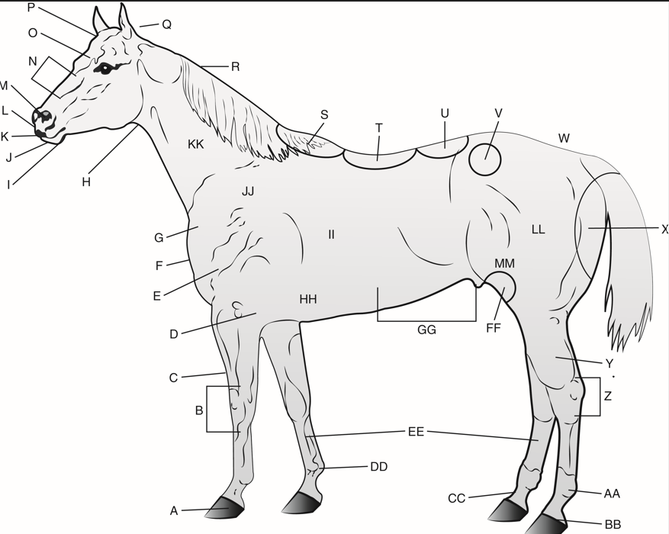
Goodheart-Willcox Publisher
- Why should feed for horses be free of mold and dust? (10.3.5)
Answer:
- True or False? The person who trims hooves and shoes horses is called a farrier. (10.3.5)
Answer:
- True or False? The frog in a horse hoof works to cushion the bones in the bottom of the leg. (10.3.5)
Answer:
- True or False? For proper hoof care, hooves should be trimmed or reshod every 6–8 weeks. (10.3.5)
Answer:
Label the parts of an equine hoof. (10.3.5)
- Bars
Answer:
- Bulb of heel
Answer:
- Frog
Answer:
- Quarter
Answer:
- Sole
Answer:
- Toe
Answer:
- Wall
Answer:
- White line
Answer:
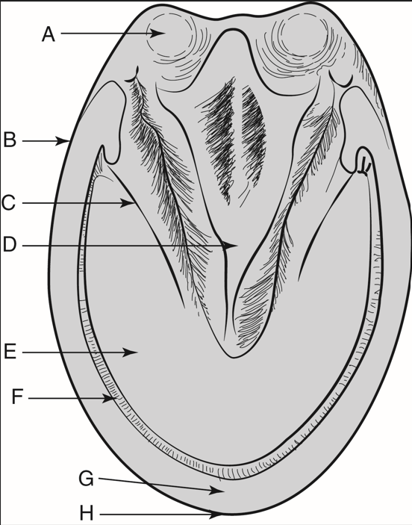
Goodheart-Willcox Publisher

- Why could standing directly in front of or behind a horse spook it? (10.3.6)
Answer:
- Why should wild horses be called feral horses? (10.3.7)
Answer:
Match the type of horse to its definition.
- Long-eared breeds
- Pony
- Light horses
- Draft horses
- Sixteen to eighteen hands tall and may weigh upwards of 2,000 lb (10.3.8)
Answer:
- Equines from the Equus asinus species (10.3.8)
Answer:
- Around 14 to 16 hands tall and between 900 and 1400 lb (10.3.8)
Answer:
- Horses under 14.2 hands tall and weighing up to 900 lb (10.3.8)
Answer:

Critical Thinking
- Explain why mules cannot reproduce. (10.3.8)
Answer:

