Name:
Class:
Date:

Lesson 11.1: The Poultry Industry

Lesson Review
Carefully study the lesson and then answer the following questions.
- List five types of birds that are commercially raised in the poultry industry. (11.1.1)
Answer:
Match the term to its definition. (11.1.1)
- Broiler
- Capon
- Chick
- Cockerel
- Flock
- Hen
- Layer
- Pullet
- Rooster
- Chicken raised for laying eggs (11.1.1)
Answer:
- Male chicken under one year old (11.1.1)
Answer:
- Baby chicken (11.1.1)
Answer:
- Adult male chicken (11.1.1)
Answer:
- Chicken raised strictly for meat (11.1.1)
Answer:
- Adult female chicken over a year old (11.1.1)
Answer:
- A number of chickens feeding and living together (11.1.1)
Answer:
- Castrated male chicken (11.1.1)
Answer:
- Female under one year old (11.1.1)
Answer:
- On average, how much do American consumers spend on chicken each year? (11.1.1)
- $57 billion
- $63 billion
- $70 billion
- $84 billion
Answer:
- List the top five states in broiler production. (11.1.1)
Answer:
- What does it mean if a poultry producer is using vertical integration? (11.1.1)
Answer:
- True or False? To maintain desired quality, poultry companies either grow their own chickens or hire contract growers. (11.1.1)
Answer:
- True or False? Vertically integrated poultry companies leave sanitation and health standards up to the individual contract growers. (11.1.1)
Answer:
- True or False? In the 1920s and 1930s hens were laying approximately 150 eggs per year. (11.1.1)
Answer:
- Approximately how many egg-producing companies are there currently in the United States? (11.1.1)
- 67
- 138
- 192
- 223
Answer:
- How many eggs can a molted chicken produce in its commercial lifetime? (11.1.1)
- 120
- 280
- 350
- 530
Answer:
- List the top five states in layer production. (11.1.1)
Answer:
- Where does the production process begin for broilers and layers? (11.1.2)
- Breeder farms
- Hatcheries
- Home breeders
- Laying houses
Answer:
- What factor will most often impact the design of the poultry houses used for breeding? (11.1.2)
- Number of eggs produced
- Species of birds
- Demand for poultry products
- Requirement for litter
Answer:
- Explain candling. (11.1.2)
Answer:
- The incubation period for chicken eggs is approximately _____ days. (11.1.2)
- 21
- 23
- 25
- 28
Answer:
- True or False? Commercial egg producers use lights to stimulate higher levels of egg production. (11.1.2)
Answer:
Match each avian digestive part to its function. (11.1.3)
- Caeca
- Cloaca
- Crop
- Gizzard
- Proventriculus
- Digestive enzymes and chemicals are added
Answer:
- Storage area at the bottom of the esophagus
Answer:
- Opening at the end of the avian digestive system
Answer:
- Muscular pouch where contractions and rocks mechanically break down food
Answer:
- Section of the large intestine where waste products from the kidneys enter
Answer:
Match the labeled poultry anatomy to its correct term. (11.1.3)
- Brain
Answer:
- Caeca
Answer:
- Cloaca
Answer:
- Crop
Answer:
- Duodenal loop
Answer:
- Esophagus
Answer:
- Eye
Answer:
- Gall bladder
Answer:
- Gizzard
Answer:
- Heart
Answer:
- Kidney
Answer:
- Large intestine
Answer:
- Larynx
Answer:
- Liver
Answer:
- Lungs
Answer:
- Nostril
Answer:
- Ovary
Answer:
- Oviduct
Answer:
- Pancreas
Answer:
- Proventriculus
Answer:
- Small intestine
Answer:
- Spleen
Answer:
- Trachea
Answer:
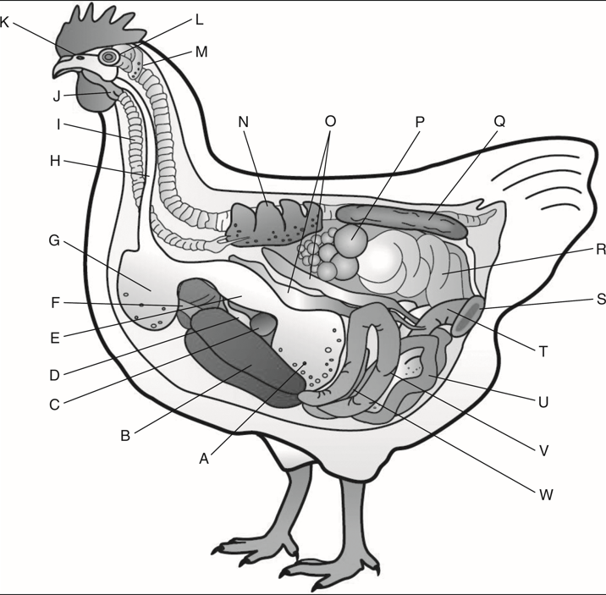
Poultry CRC

- What is the difference between free-range systems, semi-intensive housing systems, and intensive housing systems? (11.1.6)
- Free-range
Answer:
- Semi-intensive
Answer:
- Intensive
Answer:
- The percentage of chickens produced in the United States in free-range systems amounts to _____. (11.1.6)
- less than 1%
- 2%
- 10%
- 25%
Answer:
- True or False? Poultry litter can be used as low-cost fertilizer but cannot be used as a biomass source. (11.1.6)
Answer:
- True or False? Game birds are different species and subspecies of fowls that are legally hunted. (11.1.11)
Answer:

Critical Thinking
- Look at the list of top states for both broiler and layers. Are they from the same or different regions of the country? What could you infer about the differences in producing broilers and layers from these differences? (11.1.1)
Answer:

