Name:
Class:
Date:

Lesson 11.2: The Swine Industry

Lesson Review
Carefully study the lesson and then answer the following questions.
- The _____ region of the United States produces the most swine. (11.2.1)
- Corn Belt
- Deep South
- Rocky Mountains
- New England
Answer:
- List the top five states in swine production. (11.2.1)
Answer:
Match each of the following terms to its definition. (11.2.1)
- Barrow
- Boar
- Farrowing
- Gilt
- Pig or piglet
- Pork
- Sow
- Immature or mature male (11.2.1)
Answer:
- Immature female (11.2.1)
Answer:
- The process of giving birth (11.2.1)
Answer:
- Castrated male (11.2.1)
Answer:
- Young of either gender (11.2.1)
Answer:
- Meat from swine (11.2.1)
Answer:
- Mature female (11.2.1)
Answer:
- The average gestation for a sow is _____ days. (11.2.2)
- 86
- 114
- 142
- 174
Answer:
- List three tasks that are performed during the processing of piglets to promote continued growth and health. (11.2.2)
Answer:
- Market hogs are typically sent to harvest around _____. (11.2.2)
- 200–240 pounds
- 220–260 pounds
- 240–280 pounds
- 300–320 pounds
Answer:
- List the age at which the following things occur in swine production.
- Weaning (11.2.2):
Answer:
- Moved from nursery to grower-finisher area (11.2.2):
Answer:
- True or False? Many of the swine produced in the United States are produced in outdoor facilities. (11.2.3)
Answer:
- True or False? Confined swine operations can increase animal welfare practices. (11.2.3)
Answer:
- True or False? The use of farrowing crates decreases the chances of a sow lying on and killing piglets. (11.2.3)
Answer:
- What are the two distinct categories of the swine industry? (11.2.5)
Answer:
Match each type of swine operation to its definition. (11.2.5)
- Farrow-to-finish operations
- Feeder pig operations
- Finishing operations
- Purebred operations
- Produce seedstock with documented pedigrees for other breeders.
Answer:
- Swine herd has sows farrowing year-round and offspring raised to market weight.
Answer:
- Pigs are purchased at about 25 lb and fed to a desirable market weight.
Answer:
- Piglets are raised until weaning then sold to a finishing operation.
Answer:
- True or False? There are specific organizations formed to help consolidate and manage swine breeds and pedigrees. (11.2.5)
Answer:
- True or False? Water matters less to the overall health of swine than in other livestock species. (11.2.5)
Answer:
Label the external anatomy of swine. (11.2.6)
- Blade
Answer:
- Chest floor/sternum
Answer:
- Elbow pocket
Answer:
- Flank
Answer:
- Foot
Answer:
- Forearm
Answer:
- Ham
Answer:
- Hip
Answer:
- Hock
Answer:
- Jawline
Answer:
- Knee
Answer:
- Loin
Answer:
- Lower body cavity
Answer:
- Pastern
Answer:
- Stifle
Answer:
- Tail set
Answer:
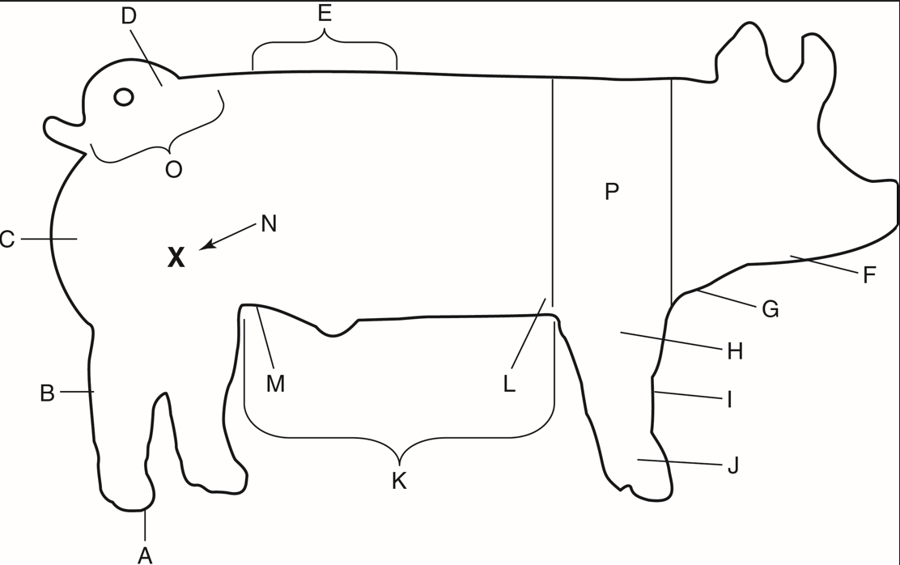
TAMU Livestock Judging
- True or False? Swine do not sweat. (11.2.7)
Answer:
- True or False? Biosecurity helps prevent the spread of disease in swine production. (11.2.7)
Answer:
- True or False? Sows have very stable demeanors and are unlikely to be aggressive. (11.2.7)
Answer:
- True or False? The Boston butt of pork comes from the ham. (11.2.9)
Answer:

Critical Thinking
- What structural changes would lead to a market hog having more bacon? (11.2.9)
Answer:

