Name:
Class:
Date:

Lesson 11.3: The Sheep Industry

Lesson Review
Carefully study the lesson and then answer the following questions.
- On average, Americans consume _____ of lamb or mutton each year. (11.3.1)
- 1 lb
- 5 lb
- 10 lb
- 25 lb
Answer:
- True or False? Americans consume, on average, more lamb and mutton per person than countries such as Australia or New Zealand. (11.3.1)
Answer:
- True or False? US lamb and mutton consumption has increased in the last 50 years. (11.3.1)
Answer:
- What are the two main purposes for raising sheep? (11.3.1)
Answer:
- List the top five wool-producing counties in the world. (11.3.1)
Answer:
- Which US state produces the most wool? (11.3.1)
- Wyoming
- Illinois
- Texas
- California
Answer:
- In its raw state, wool is called _____ wool. (11.3.1)
- fleece
- plain
- greasy
- sheared
Answer:
- True or False? Wool quality varies only slightly from region to region or breed to breed. (11.3.1)
Answer:
Match each of the terms to its definition. (11.3.1)
- Ewe
- Ewe lamb
- Flock
- Lamb
- Lambing
- Mutton
- Ram
- Ram lamb
- Wether
- Castrated male
Answer:
- Mature female
Answer:
- Young of either gender, or meat from a sheep under one year old
Answer:
- Young female
Answer:
- Young male
Answer:
- Giving birth
Answer:
- Mature male
Answer:
- Meat from a sheep over one year old
Answer:
- Group of sheep
Answer:
- The gestation of a ewe is _____ days. (11.3.2)
- 100
- 125
- 150
- 175
Answer:
- Sheep are seasonal breeders; this means that their breeding is influenced by _____. (11.3.2)
- the phase of the moon
- summer rainfall
- shifts in daily temperature
- the length of day
Answer:
- What is the difference between range production and farm flocks? (11.3.3)
Answer:
- What is the main goal of purebred producers? (11.3.3)
Answer:
- Sheep have a(n) _____ digestive system. (11.3.4)
- avian
- modified monogastric
- monogastric
- ruminant
Answer:
Label the external anatomy of sheep. (11.3.4)
- Chest floor
Answer:
- Dock
Answer:
- Face/eye channel
Answer:
- Flank
Answer:
- Forerib
Answer:
- Hindsaddle
Answer:
- Hip
Answer:
- Hock
Answer:
- Hoof
Answer:
- Knee
Answer:
- Leg
Answer:
- Loin
Answer:
- Middle
Answer:
- Muzzle
Answer:
- Neck
Answer:
- Pastern
Answer:
- Point of shoulder
Answer:
- Rack
Answer:
- Top of shoulder
Answer:
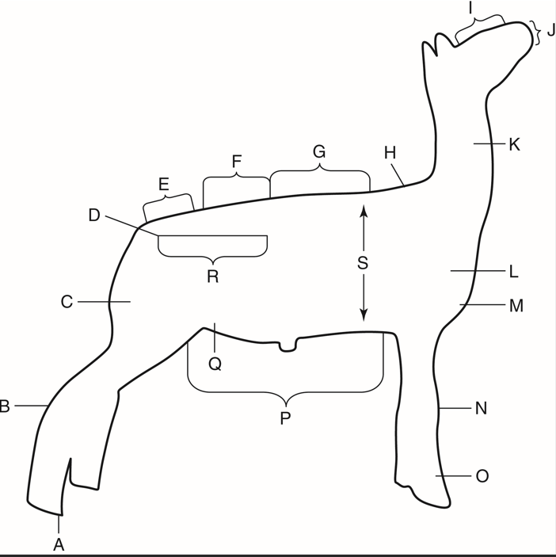
TAMU Livestock Judging
- The number of animals on a given amount of land over a certain period of time is called the _____. (11.3.4)
- quarantine number
- stocking rate
- range number
- flock size
Answer:
- True or False? It is easy to separate several sheep from the flock. (11.3.5)
Answer:
- True or False? Sheep will try to stay in well-lit areas. (11.3.5)
Answer:
- True or False? The term flight zone refers to how close you can get to sheep before they start moving. (11.3.5)
Answer:
- List three important primal cuts of lamb or mutton. (11.3.6)
Answer:
- List one breed of sheep for each of the following types. (11.3.6)
- Fine-wool
Answer:
- Long-wool
Answer:
- Medium-wool
Answer:
- Crossbred-wool
Answer:
- Hair
Answer:

Critical Thinking
- Why do you think the consumption of lamb and mutton is so different in the United States compared to countries such as Australia and New Zealand? (11.3.1)
Answer:

