Name:
Class:
Date:

Lesson 11.4: The Goat Industry

Lesson Review
Carefully study the lesson and then answer the following questions.
- True or False? It is easy to estimate the number of goats in the United States. (11.4.1)
Answer:
- True or False? There are somewhere around 2.5 million goats in the United States. (11.4.1)
Answer:
- True or False? Specific cultures have a large impact on goat production numbers in the United States. (11.4.2)
Answer:
Match each of the terms to its definition. (11.4.1)
- Billy or buck
- Cabrito
- Kid
- Kidding
- Nanny or doe
- Wether
- Castrated male
Answer:
- Female goat of any age
Answer:
- Young of either gender
Answer:
- Young milk-fed goat
Answer:
- Male goat of any age
Answer:
- The process of giving birth
Answer:
- The gestation period of a goat is _____ days. (11.4.1)
- 100
- 125
- 150
- 175
Answer:
- True or False? Multiple births (twins and triplets) are uncommon in goats. (11.4.3)
Answer:
- Kids stay with the doe for _____. (11.4.3)
- 6–8 weeks
- 8–10 weeks
- 10–12 weeks
- 12–14 weeks
Answer:
- What are the four main sectors of the goat industry? (11.4.4)
Answer:
- True or False? There are declining numbers of hair and fiber goats in the United States. (11.4.4)
Answer:
Label the external anatomy of goats. (11.4.5)
- Barrel
Answer:
- Brisket
Answer:
- Chest floor
Answer:
- Chine
Answer:
- Chop
Answer:
- Dew claw
Answer:
- Elbow
Answer:
- Flank
Answer:
- Heart girth
Answer:
- Heel
Answer:
- Hock
Answer:
- Jaw
Answer:
- Knee
Answer:
- Loin
Answer:
- Muzzle
Answer:
- Neck
Answer:
- Pin bone
Answer:
- Point of shoulder
Answer:
- Rump
Answer:
- Sheath
Answer:
- Sole
Answer:
- Stifle
Answer:
- Thigh
Answer:
- Throat
Answer:
- Thurl
Answer:
- Toe
Answer:
- Withers
Answer:
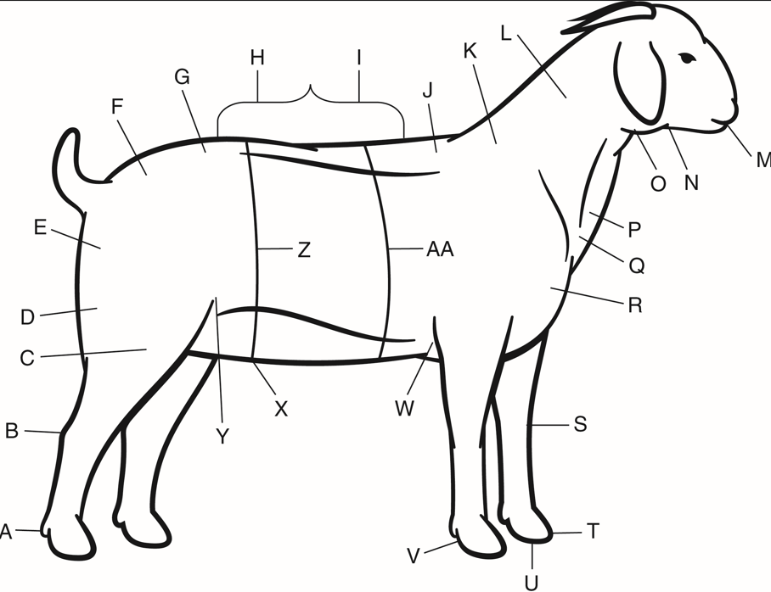
Vlad Klok/Shutterstock.com
- Goats have a(n) _____ digestive system. (11.4.5)
- avian
- modified monogastric
- monogastric
- ruminant
Answer:
- The process of eating leaves, twigs, and shoots of plants is called _____. (11.4.5)
- browsing
- grazing
- range-eating
- selective-grazing
Answer:
- True or False? It is easier to handle goats than sheep. (11.4.5)
Answer:
- True or False? Goats will generally move together, with the older animals leading the way. (11.4.5)
Answer:
- True or False? The term flight zone refers to how close you can get to goats before they start moving. (11.4.5)
Answer:
- Meat from an adult goat is called _____. (11.4.6)
- cabrito
- mutton
- chevon
- kid
Answer:
- List one breed of goat for each of the following types. (11.4.7)
- Meat
Answer:
- Dairy
Answer:
- Angora
Answer:

Critical Thinking
- What do you think will happen to the number of goats in the United States in the next 15 to 20 years? Explain your response. (11.4.1)
Answer:

