Name:
Class:
Date:

Lesson 13.1: Plant Anatomy and Physiology

Lesson Review
Carefully study the lesson and then answer the following questions.
- Scientists estimate there are _____ different plant species. (13.1.0)
- about 200,000
- more than 300,000
- nearly 500,000
- about 1,000,000
Answer:
Match the types of plant tissue to their function. (13.1.1)
- Epidermal tissue
- Ground tissue
- Vascular tissue
- Transports materials around the plant much like blood vessels in an animal’s body
Answer:
- The outside covering of a plant
Answer:
- Includes all the plant parts that perform photosynthesis
Answer:
- What is the difference between xylem and phloem? (13.1.1)
Answer:
Match the terms with their definition. (13.1.1)
- Apical meristem
- Intercalary meristem
- Lateral meristem
- Meristematic tissue
- Undifferentiated plant cells that are capable of dividing independently
Answer:
- Tissue found at the tips of roots and shoots of the plant
Answer:
- Tissue found at the tube-like shape along the stem of woody plants
Answer:
- Tissue found in the nodes of the plants or the places where leaves and branches attach to the main stem of the plant
Answer:
- List the four main plant parts. (13.1.2)
Answer:
- The main portion of the root is called the _____. (13.1.2)
- taproot
- vascular bundle
- primary root
- meristem
Answer:
- Explain the difference between taproots and fibrous roots. (13.1.2)
Answer:
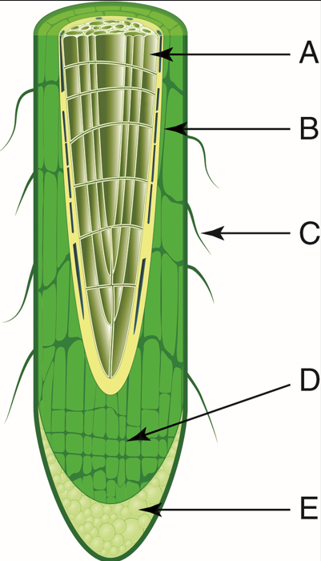
Designua/Shutterstock.com
Label the parts of the root tip. (13.1.2)
- Area of dividing cells
Answer:
- Phloem
Answer:
- Root cap
Answer:
- Root hair
Answer:
- Xylem
Answer:

Label the parts of a leaf.
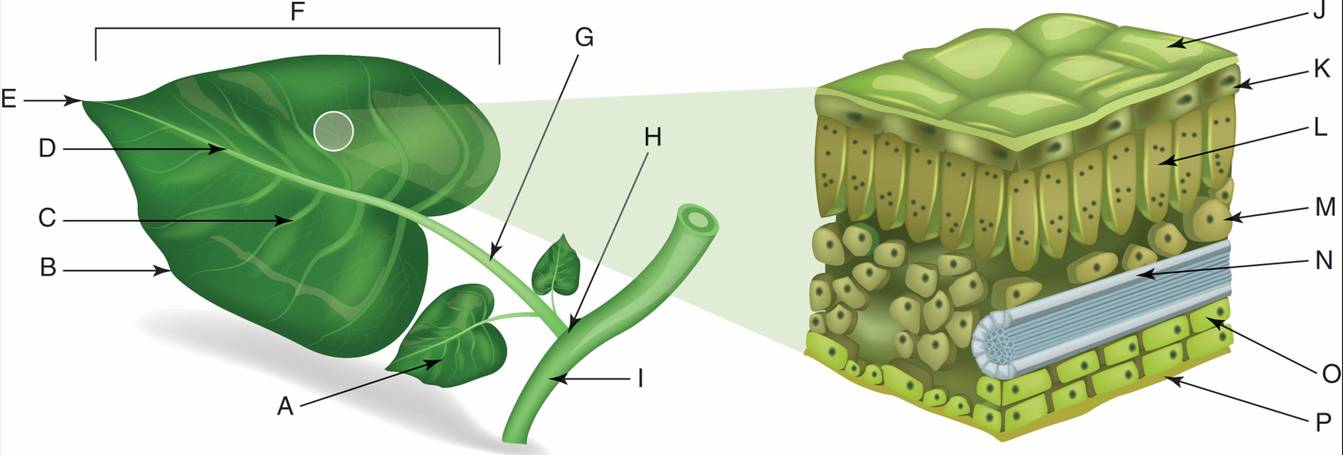
Anshuman Rath/Shutterstock.com
- Apex
Answer:
- Axil
Answer:
- Blade
Answer:
- Leaf margin
Answer:
- Lower cuticle
Answer:
- Lower epidermis
Answer:
- Midrib
Answer:
- Palisade
Answer:
- Petiole
Answer:
- Spongy mesophyll
Answer:
- Stem
Answer:
- Stipule
Answer:
- Upper cuticle
Answer:
- Upper epidermis
Answer:
- Vascular bundle
Answer:
- Vein
Answer:
- True or False? Xylem and phloem create the annual rings of trees. (13.1.2)
Answer:
- True or False? The place on a stem where a leaf, flower, or main branch may occur is called an internode. (13.1.2)
Answer:
- True or False? Potatoes are actually modified stems. (13.1.2)
Answer:
- True or False? Rhizomes are tall, vertical stems without nodes. (13.1.2)
Answer:
- What happens in each of the four main layers of leaves? (13.1.2)
- Cuticle
Answer:
- Palisade layer
Answer:
- Mesophyll
Answer:
- Lower epidermis
Answer:
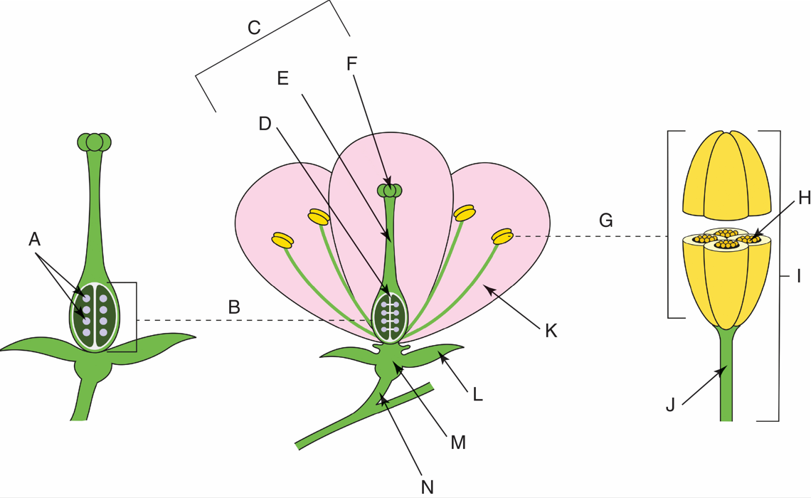
Aldona Griskeviciene/Shutterstock.com
Label the parts of the flower. (13.1.2)
- Anther
Answer:
- Filament
Answer:
- Ovary
Answer:
- Ovary
Answer:
- Ovule
Answer:
- Pedicel
Answer:
- Petal
Answer:
- Pistil
Answer:
- Pollen grain
Answer:
- Receptacle
Answer:
- Sepal
Answer:
- Stamen
Answer:
- Stigma
Answer:
- Style
Answer:
Match the types of flowers to their definition. (13.1.3)
- Composite flowers
- Pistillate flowers
- Staminate flowers
- Flowers with only male reproductive parts
Answer:
- Flowers made of many small flowers in one large “flower” structure
Answer:
- Flowers with only female reproductive parts
Answer:
- Explain the difference between a monocot and a dicot. (13.1.4)
Answer:
- How much time does each of the following plant types require to complete its growth cycle? (13.1.4)
- Annual
Answer:
- Biennial
Answer:
- Perennial
Answer:
- _____ is the process of converting light energy to chemical energy and storing it in the form of sugar. (13.1.5)
- Chlorophyll
- Chloroplast
- Autotroph
- Photosynthesis
Answer:
- An organism that can make its own nutrients is called a(n) _____. (13.1.5)
- chlorophyll
- chloroplast
- autotroph
- phototroph
Answer:
- The substance that absorbs sunlight to help complete the process of photosynthesis is _____. (13.1.5)
- chlorophyll
- chloroplasm
- autoplasm
- carbon
Answer:
- What is the chemical formula for photosynthesis? (13.1.5)
Answer:
- List three factors that can contribute to the rate of photosynthesis. (13.1.5)
Answer:
- True or False? Mature plant tissue growing into an exact copy of the plant is considered sexual reproduction. (13.1.5)
Answer:
- True or False? New plants can be recreated from a single plant cell. (13.1.5)
Answer:
- True or False? Plants create sex cells through the process of meiosis. (13.1.5)
Answer:
- True or False? Leaves house the reproductive parts of a plant. (13.1.5)
Answer:
- True or False? A single pollen grain is all that is required to pollinate a plant. (13.1.5)
Answer:

Critical Thinking
- Which reproduction method is better for creating new plants? Give an example of a situation where sexual reproduction would be the best method to use. Give an example of a situation where asexual reproduction would be the best method. (13.1.5)
Answer:

