Name:
Class:
Date:

Lesson 14.3: Ecological Cycles

Lesson Review
Carefully study the lesson and then answer the following questions.
- What is a biogeochemical cycle? (14.3.1)
Answer:
- True or False? A cycle is a circular flow of information used to create chemicals. (14.3.1)
Answer:
- True or False? The biosphere is the accumulation of all of Earth’s ecosystems. (14.3.1)
Answer:
- True or False? The total amount of nitrogen, carbon, oxygen, and water is completely unstable. (14.3.1)
Answer:
- True or False? The usable and clean quantities of important nutrients are always in flux. (14.3.0)
Answer:
Identify the components of the water cycle. (14.3.2)
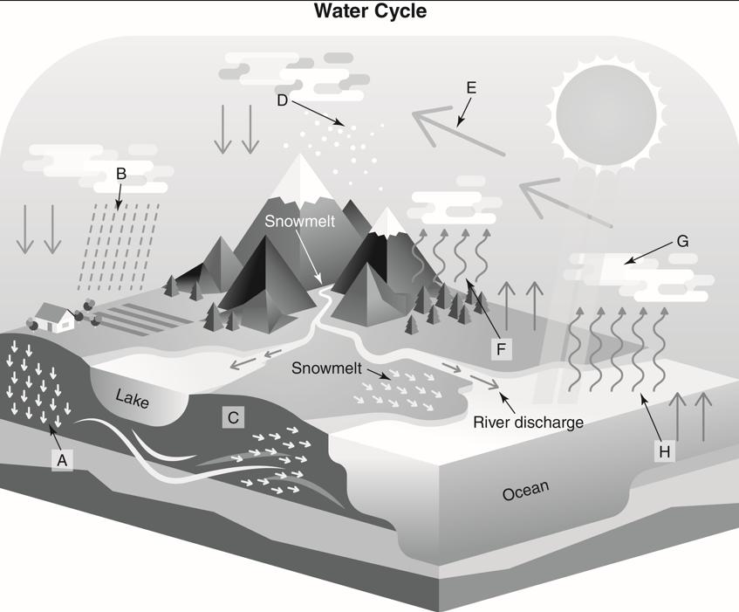
VectorMine/Shutterstock.com
- Condensation
Answer:
- Evaporation
Answer:
- Percolation
Answer:
- Infiltration into groundwater
Answer:
- Precipitation
Answer:
- Deposition
Answer:
- Transpiration
Answer:
- Transport
Answer:
- What portion of the water on Earth is frozen? (14.3.2)
- 1/4
- 1/2
- 3/4
- 7/8
Answer:
- The process used to remove salt from seawater is called _____. (14.3.2)
- hydrology
- precipitation
- compression
- desalination
Answer:
- Groundwater is stored in underground reservoirs called _____. (14.3.2)
- aquifers
- groundwater
- gaseous water
- water caves
Answer:
- What is the difference between runoff water and surface water? (14.3.2)
Answer:
- True or False? Acid rain can be a natural phenomenon. (14.3.2)
Answer:
- True or False? Lakes are large enough that acid rain can have no bearing on their overall acidity. (14.3.2)
Answer:
- True or False? Water rights are of greater concern in areas with a limited water supply. (14.3.2)
Answer:
- True or False? Plants can obtain and use nitrogen directly from the atmosphere. (14.3.3)
Answer:
- Explain what happens in each of the four stages of the nitrogen cycle. (14.3.3)
- Fixation
Answer:
- Ammonification
Answer:
- Nitrification
Answer:
- Denitrification
Answer:
- What two problems can excess nitrogen in water supplies cause? (14.3.3)
Answer:
- Explain the difference between a carbon pool, a carbon sink, and a carbon source. (14.3.4)
- Carbon pool
Answer:
- Carbon sink
Answer:
- Carbon source
Answer:
- True or False? Of all the carbon pools, the carbon held in carbon sinks causes the most concern for human life. (14.3.4)
Answer:
- True or False? Carbon dioxide and methane are among the most dangerous greenhouse gases. (14.3.4)
Answer:
- List three types of methane sources in the atmosphere. (14.3.4)
Answer:

Critical Thinking
- The carbon credit system allows companies to examine their carbon usage. What are some things that agriculturalists could do to decrease their carbon usage? (14.3.4)
Answer:

