Name:
Class:
Date:

Activity 14.5A: Food Chains and Food Webs

Instructions
Food chains show the relationship between producers (plants), primary consumers (animals that eat plants), and secondary consumers (animals that eat other animals).
Example: seeds → sparrow → hawk → fox
A food web is a series of interconnected food chains.
Example:
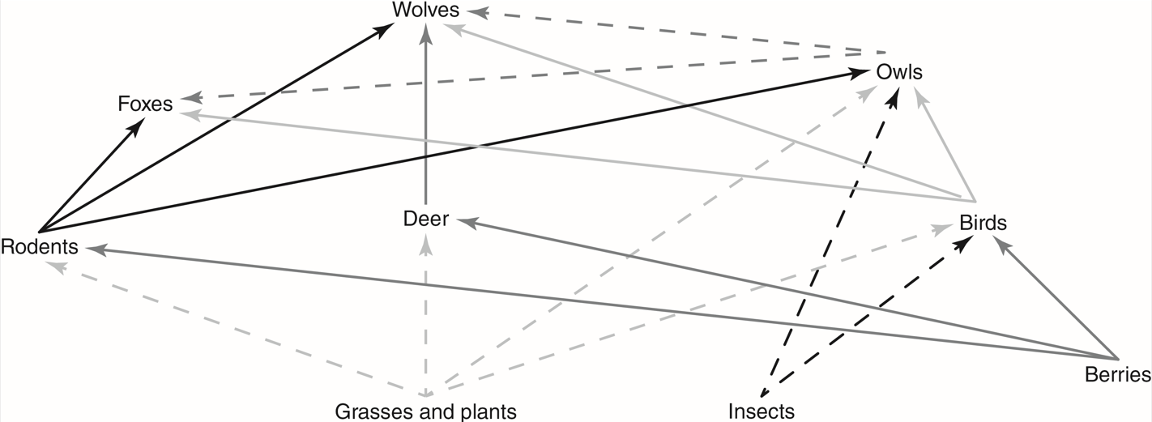
Goodheart-Willcox Publisher

Create five food chains, each with at least four organisms. Each chain must also include at least one producer, one primary consumer, and one secondary consumer.
- Food chain
Answer:
- Food chain
Answer:
- Food chain
Answer:
- Food chain
Answer:
- Food chain
Answer:
- Draw a food web with at least 15 different organisms.

