Name:
Class:
Date:

Activity 15.2A: Edible Soil Profile Lab Worksheet

Materials Needed
- Clear plastic cup
- 1 chocolate sandwich cookie
- Crumbled chocolate chip cookies
- Vanilla pudding
- Chocolate pudding
- Gummy worms
- Sprinkles
- Spoons and/or spatulas

Section One: Soil Formation
Answer the following questions using information from your notes.
- List the five factors that influence soil formation.
Answer:
- Which factor is most important in soil formation? Explain your answer.
Answer:

Section Two: Soil Horizon Creation
Follow the instructions to create a soil horizon model and then answer the questions about your model. Wash your hands before you begin.
- Construct an edible soil profile as follows. Do not eat until given permission.
- Place the sandwich cookie (Horizon R) in the bottom of a plastic cup.
- Place a layer of crumbled chocolate chip cookies (Horizon C) on top of the sandwich cookie.
- Place a layer of vanilla pudding (Horizon B) on top of the crumbled chocolate chip cookies.
- Place a layer of chocolate pudding (Horizon A) on top of the vanilla pudding.
- Add sprinkles (Horizon O) and place 2 to 3 gummy worms on the top.

Complete the following worksheet about the function of soil horizons found in your model.
- Horizon O (sprinkles/worms)
Function in Soil
Answer:
- Horizon A (chocolate pudding)
Function in Soil
Answer:
- Horizon B (vanilla pudding)
Function in Soil
Answer:
- Horizon C (crumbled cookies)
Function in Soil
Answer:
- Horizon R (sandwich cookie)
Function in Soil
Answer:

Section Three: Analysis and Conclusion
Complete the following upon conclusion of the lab.
- Draw, color, and label the horizons of your edible soil.
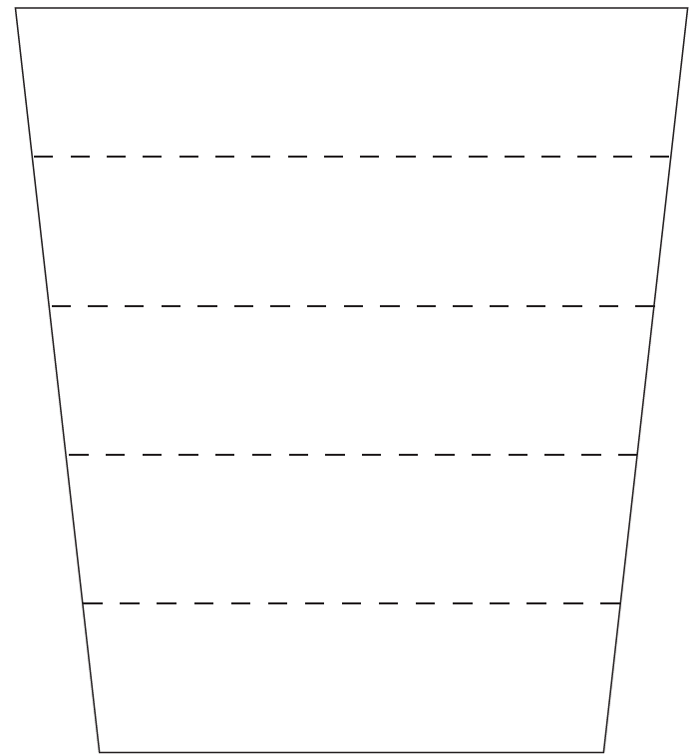
Goodheart-Willcox Publisher
- Discuss the use of each of the components of your model. Explain why each material was used to represent each layer.
- Chocolate pudding
Horizon
Answer:
Why was this material used?
Answer:
- Vanilla pudding
Horizon
Answer:
Why was this material used?
Answer:
- Sandwich cookie
Horizon
Answer:
Why was this material used?
Answer:
- Sprinkles
Horizon
Answer:
Why was this material used?
Answer:
- Gummy worms
Horizon
Answer:
Why was this material used?
Answer:
- Chocolate chip cookies
Horizon
Answer:
Why was this material used?
Answer:

