Name:
Class:
Date:

Activity 15.4A: Groundwater Infiltration Lab

Materials Needed
- “Contaminated” water
- Charcoal
- Coffee filters
- Cotton
- Empty water bottles with bottoms removed (2 per student/group)
- Gravel
- Rubber bands
- Scissors
- Screen
- Soil

Section One
Answer the following questions.
- Define infiltration.
Answer:
- List three factors that contribute to the success of infiltration.
Answer:

Section Two
Using the “bottle” diagrams, draw and label the layers you will be using in your filtration system. Each group is allowed to do two design attempts.

System #1
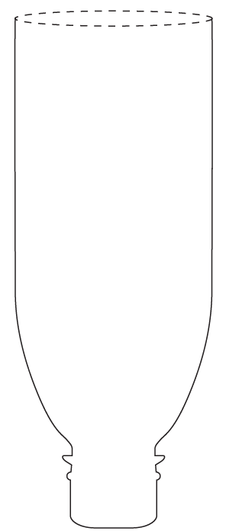
Goodheart-Willcox Publisher
- What do you think is the most successful part of this design?
Answer:
- Layer the materials in one of your water bottles in the same configuration as your design.
- What was left in the water after the first filtration?
Answer:
- Rank the color on a scale of 1 to 5 (1 being very clear) after the first filtration.
Answer:
- What was left in the water after the second filtration?
Answer:
- Rank the color on a scale of 1 to 5 (1 being very clear) after the second filtration.
Answer:

System #2
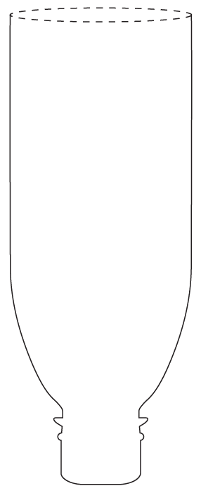
Goodheart-Willcox Publisher
- What do you think is the most successful part of this design?
Answer:
- Layer the materials in one of your water bottles in the same configuration as your design.
- What was left in the water after the first filtration?
Answer:
- Rank the color on a scale of 1 to 5 (1 being very clear) after the first filtration.
Answer:
- What was left in the water after the second filtration?
Answer:
- Rank the color on a scale of 1 to 5 (1 being very clear) after the second filtration.
Answer:

Section Three
Answer the following questions.
- What is the best component of filtration?
Answer:
- What was the hardest contaminant to remove?
Answer:
- Search online to determine how activated charcoal works. Explain why activated charcoal is common in water filters.
Answer:

