Name:
Class:
Date:

Activity 15.5A: Soil Erosion Lab

Materials Needed
- Grass sod (or an area where grass can be dug up)
- Hole punch or awl
- Measuring cup
- Mulch, leaves, and/or other organic matter
- Potting soil
- Scissors
- String
- Three small empty water bottles per group
- Three empty two-liter bottles per group
- Timer (one per group)

Step One: Prepare Soil Containers
- Remove and discard the bottle caps from each of the two-liter bottles.
- Cut each of the three two-liter bottles so they are open along the length of one whole side.
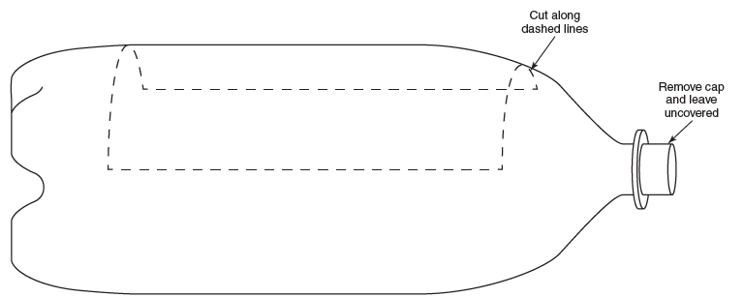
Goodheart-Willcox Publisher

Step Two: Fill the Soil Containers
- Fill two of the bottles with potting soil so that the top of the soil is level with the opening at the top of the bottle.
- Top off one of the bottles containing soil with mulch.
- In the third bottle, pack the grass/sod with soil attached into the cut opening.
- Place the three bottles along the edge of a desk or table with the open ends hanging over the edge.
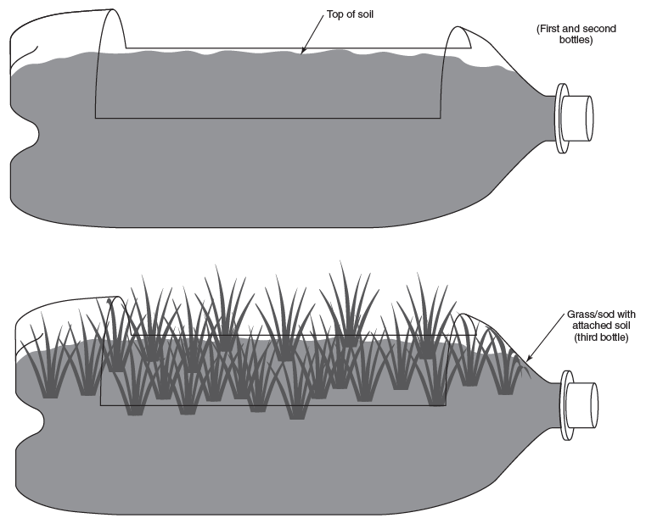
Goodheart-Willcox Publisher

Step Three: Prepare Water Collection Devices
- Cut and discard the top half of all three water bottles.
- Punch a hole on one side of the bottle (near the cut line). Punch another hole directly across from the first hole.
- Cut a 10 inch piece of string and tie it securely through the punched holes.
- Hang the water collection devices from the open ends of the two-liter bottles.
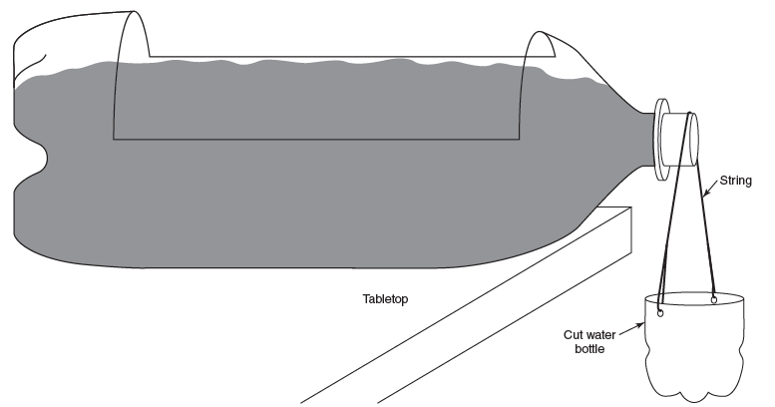
Goodheart-Willcox Publisher

Step Four: Conduct the Experiment
- You will need to observe water flow in each bottle and record the data on the chart provided (see following page). Before pouring water into the containers, review the worksheet to ensure you observe and record the necessary data.
- Set your timer.
- Activate the timer as you begin slowly pouring two cups of water into the first two-liter bottle (at the end opposite the opening). Record the data.
- Repeat the process for each of the bottles.
- Grass Treatment
- Time for water to reach the collection device
Answer:
- Amount of water in the collection device (use a measuring cup)
Answer:
- Water sediment observation
Answer:
- Mulch Treatment

- Time for water to reach the collection device
Answer:
- Amount of water in the collection device (use a measuring cup)
Answer:
- Water sediment observation
Answer:
- Soil Only Treatment
- Time for water to reach the collection device
Answer:
- Amount of water in the collection device (use a measuring cup)
Answer:
- Water sediment observation
Answer:

Step Five: Replicate the Experiment
- Empty the water collection devices.
- Set your timer.
- Activate the timer as you begin slowly pouring two cups of water into the first two-liter bottle (at the end opposite the opening). Record the data.
- Repeat the process for each of the bottles.
- Grass Treatment
- Time for water to reach the collection device
Answer:
- Amount of water in the collection device (use a measuring cup)
Answer:
- Water sediment observation
Answer:
- Mulch Treatment
- Time for water to reach the collection device
Answer:
- Amount of water in the collection device (use a measuring cup)
Answer:
- Water sediment observation
Answer:
- Soil Only Treatment
- Time for water to reach the collection device
Answer:
- Amount of water in the collection device (use a measuring cup)
Answer:
- Water sediment observation
Answer:

Step Six: Conclusion
Answer the following questions.
- Which treatment has the most soil erosion?
Answer:
- Which treatment has the least soil erosion?
Answer:
- How does this lab relate to the methods farmers use to prevent soil erosion?
Answer:

