Name:
Class:
Date:

Lesson 16.1: Forest Production

Lesson Review
Carefully study the lesson and then answer the following questions.
- What is silviculture? (16.1.1)
Answer:
- What percentage of the United States is covered by forests? (16.1.0)
- 18%
- 27%
- 33%
- 46%
Answer:
Match the term to its definition.
- Hardwood species
- Lumber
- Pulpwood
- Sawlogs
- Softwood species
- Veneer
- Timber that has been sawn into long boards for planks, typically used in construction and furniture (16.1.1)
Answer:
- Coniferous trees that do not shed leaves (16.1.1)
Answer:
- Thin layer of decorative wood that is glued over the surface of other wood (16.1.1)
Answer:
- Smaller coniferous trees grown to produce paper and paper products (16.1.1)
Answer:
- Logs sawn into lumber used for building houses, furniture, or other wood products (16.1.1)
Answer:
- Trees that grow new leaves in the spring of each year (16.1.1)
Answer:
Identify the layers of the tree trunk. (16.1.2)
- Cambium
Answer:
- Heartwood
Answer:
- Inner bark
Answer:
- Outer bark
Answer:
- Sapwood
Answer:
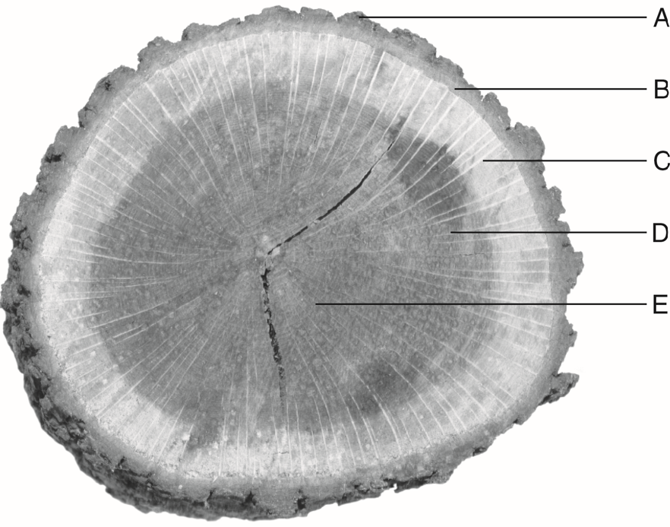
Pavel Vakhrushev/Shutterstock.com
Briefly describe the following parts of a tree. (16.1.2)
- Cambium
Answer:
- Crown
Answer:
- Heartwood
Answer:
- Inner bark
Answer:
- Outer bark
Answer:
- Sapwood
Answer:
- True or False? Trees cut for lumber are generally cut into 16′ lengths. (16.1.4)
Answer:
- True or False? Plywood is made by gluing thin sheets of wood together. (16.1.4)
Answer:
- True or False? Veneer is made by splicing short pieces of wood together with glue. (16.1.4)
Answer:
- What is mast? (16.1.4)
Answer:
- True or False? Maple syrup must be extracted from trees in warm months. (16.1.4)
Answer:
- True or False? It takes about ten gallons of sap to make one gallon of maple syrup. (16.1.4)
Answer:
- True or False? Darker maple syrups typically have a stronger maple flavor. (16.1.4)
Answer:
Match the hardwood species to its description. (16.1.5)
- Ash
- Black cherry
- Black walnut
- Hard maple
- Hickory
- Oak
- Tulip or yellow poplar
- Dark brown or purplish in color with edible nuts; wood is resistant to decay
Answer:
- Preferred wood for cutting boards, work benches, and butcher blocks
Answer:
- Famously used to make baseball bats and handles for high-impact tools
Answer:
- One of the most diverse and common tree species; used to make barrels and railroad ties
Answer:
- One of the more expensive hardwood species, used for high-end furniture
Answer:
- Easy-to-work-with, low-density hardwood; sapwood is pale yellow
Answer:
- Has an easily identifiable shaggy bark; among the hardest and strongest of woods
Answer:
Match the softwood species to its description. (16.1.5)
- Douglas fir
- Southern yellow pine
- Western red cedar
- White pine
- Most common species for constructing telephone poles
Answer:
- A mainstay of construction because of its straight growth, resistance to splitting, and lack of knots
Answer:
- Highly fragrant and resistant to decay; used commonly for shingles and home exteriors
Answer:
- Common for plywood, window frames, and Christmas trees
Answer:

Critical Thinking
- Cutting deeply into the outside of a tree on one side will not generally kill it, but cutting a ring around the tree will. Using what you know about the parts of trees, why do you think this occurs? (16.1.2)
Answer:

